## 

**CLINIC BOOKING**

**Software Requirement Specification**

## 

## 

**– Hanoi, May 2023 –**

I. Overview 8

1. Code Packages/Namespaces 8

II. Code Designs 10

1. Common Feature/Login 10

1. Class Diagram 10
2. Class Specifications 10
3. Sequence Diagram 11
4. Database Queries 11

2. Common Feature/Register 12

1. Class Diagram 12
2. Class Specification 12
3. Sequence Diagram 13
4. Database queries 14

3. Common Feature/Change Password 14

1. Class Diagram 14
2. Class Specification 15
3. Sequence Diagram 16
4. database Queries 16

4. Common Feature/ User profile 17

1. Class Diagram 17
2. Class Specification 17
3. Sequence Diagram 18
4. Database queries 18

5. Public Feature/Web Blog List 19

1. Class Diagram 19
2. Class Specification 20
3. Sequence Diagram 20
4. Database queries 21

6. Common Feature/Forgot Password 22

1. Class Diagram 22
2. Class Specification 22
3. Sequence Diagram 23
4. Database queries 23

7. Public Feature/Home Page 23

1. Class Diagram 23
2. Class Specification 24
3. Sequence Diagram 24
4. Database queries 25

8. Staff Feature/Doctor List 26

1. Class Diagram 26
2. Class Specification 26
3. Sequence Diagram 27
4. Database queries 27

9. Public Feature/Web Doctor List 28

1. Class Diagram 28
2. Class Specification 28
3. Sequence Diagram 29
4. Database queries 29

10. Public Feature/Web Doctor Detail 33

1. Class Diagram 33
2. Class Specification 33
3. Sequence Diagram 34
4. Database queries 35

11. Public Feature/Web Service List 35

1. Class Diagram 35
2. Class Specification 36
3. Sequence Diagram 36
4. Database queries 37

12. Doctor Feature/Patient’s doctor 38

1. Class Diagram 38
2. Class Specification 38
3. Sequence Diagram 39
4. Database queries 39

13. Doctor Feature/Patient detail 40

1. Class Diagram 40
2. Class Specification 40
3. Sequence Diagram 41
4. Database queries 42

14. Doctor Feature/My appointment 42

1. Class Diagram 42
2. Class Specification 42
3. Sequence Diagram 43
4. Database queries 44

15. Doctor Feature/My appointment Details 44

1. Class Diagram 44
2. Class Specification 44
3. Sequence Diagram 45
4. Database queries 45

16. Doctor Feature/My Feedback 45

1. Class Diagram 45
2. Class Specification 46
3. Sequence Diagram 46
4. Database queries 46

17. Admin Feature/Dashboard 47

1. Class Diagram 47
2. Class Specification 47
3. Sequence Diagram 48
4. Database queries 48

18. Admin Feature/Setting List 50

1. Class Diagram 50
2. Class Specification 50
3. Sequence Diagram 51
4. Database queries 52

19. Admin Feature/Setting Details 53

1. Class Diagram 53
2. Class Specification 53
3. Sequence Diagram 54
4. Database queries 54

20. Admin Feature/Account List 54

1. Class Diagram 54
2. Class Specification 55
3. Sequence Diagram 55
4. Database queries 56

21. Admin Feature/Account Detail 56

1. Class Diagram 56
2. Class Specification 57
3. Sequence Diagram 57
4. Database queries 58

22. Patient Feature/Book Appointment 59

1. Class Diagram 59
2. Class Specification 59
3. Sequence Diagram 60
4. Database queries 61

23. Patient Feature/Reserve 61

1. Class Diagram 61
2. Class Specification 62
3. Sequence Diagram 63
4. Database queries 63

24. Marketing Feature/Service Detail 64

1. Class Diagram 64
2. Class Specification 64
3. Sequence Diagram 64
4. Database queries 65

25. Marketing Feature/Service Add 65

1. Class Diagram 65
2. Class Specification 66
3. Sequence Diagram 66
4. Database queries 67

26. Marketing Feature/Service Edit 67

1. Class Diagram 67
2. Class Specification 67
3. Sequence Diagram 68
4. Database queries 68

27. Marketing Feature/Service List 68

1. Class Diagram 68
2. Class Specification 69
3. Sequence Diagram 70
4. Database queries 71

28. Marketing Feature/Blog List 72

1. Class Diagram 72
2. Class Specification 72
3. Sequence Diagram 73
4. Database queries 73

29. Marketing Feature/Blog detail 74

1. Class Diagram 74
2. Class Specification 74
3. Sequence Diagram 75
4. Database Queries 75

30. Marketing Feature/Blog Add 76

1. Class Diagram 76
2. Class Specification 77
3. Sequence Diagram 77
4. Database Queries 77

31. Marketing Feature/Blog Edit 78

1. Class Diagram 78
2. Class Specification 78
3. Sequence Diagram 79
4. Database queries 79

32. Common Feature/Web Blog Detail 80

1. Class Diagram 80
2. Class Specification 80
3. Sequence Diagram 81
4. Database queries 81

33. Staff Feature/Appointments List

1. Class Diagram 38
2. Class Specification 38
3. Sequence Diagram 39
4. Database queries 80

34. Staff Feature/Appointments Detail

1. Class Diagram 38
2. Class Specification 38
3. Sequence Diagram 39
4. Database queries 81

35. Staff Feature/Doctor Edit 81

1. Class Diagram 38
2. Class Specification 38
3. Sequence Diagram 39
4. Database queries 81

36. Staff Feature/Patient list

1. Class Diagram 38
2. Class Specification 38
3. Sequence Diagram 39
4. Database queries 81

37. Staff Feature/Patient details

1. Class Diagram 38
2. Class Specification 38
3. Sequence Diagram 39
4. Database queries 81

38. Staff Feature/Patient edit 81

1. Class Diagram 38
2. Class Specification 38
3. Sequence Diagram 39
4. Database queries 81

39. Staff Feature/Doctor Detail

1. Class Diagram 38
2. Class Specification 38
3. Sequence Diagram 39
4. Database queries 81

III. Database Design 81

1. Database Schema 81

2. Table Description 81

# 

# 

# 

# 

# 

# 

# **I. Overview**

## **1. Code Packages/Namespaces**

## 

***Package descriptions & package class naming conventions***

| No | Package | Description |
| --- | --- | --- |
| 1 | controller | Acts as a go-between for the service layer and the Front-end, passing on different input requests |
| 2 | dal | This component is used to get data directly FROM the database |
| 3 | configs | This component helps define configuration |
| 4 | context | This component helps connect database |
| 5 | model | This component includes interfaces used to receive data retrieved FROM the database and classes used to receive data |
| 6 | view | This component displays the front-end. |

## 

## 

## 

## 

## 

## 

## 

## 

## 

## 

## 

## 

## 

# 

# **II. Code Designs**

## **1. Common Feature/Login**

### **a.** **Class Diagram**

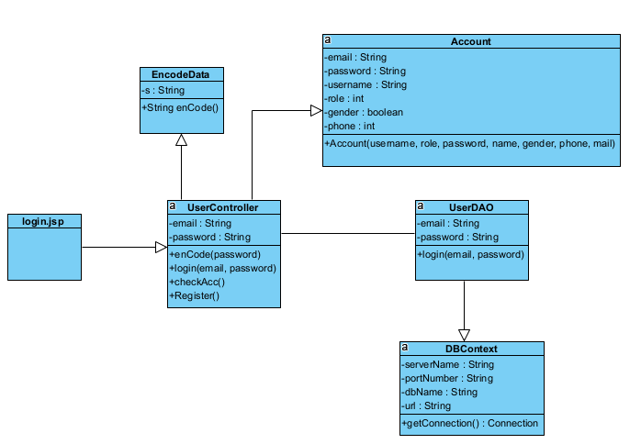

### **b.** **Class Specification**

| No | Method | Description |
| --- | --- | --- |
| 1 | Login | using to login into the system |
| 2 | check Acc | using to check account in database |
| 3 | enCode | using to encode password |
| 4 | getConnection | using to connect Database |

### **c.** **Sequence Diagram**

### **d.** **Database queries**

| No | Method | Database queries |
| --- | --- | --- |
| 1 | AccountDAO | SELECT * FROM users where email=? or username=? |

## **2. Common Feature/Register**

### **a.** **Class Diagram**

### 

### **b.** **Class Specification**

| No | Method | Description |
| --- | --- | --- |
| 1 | Register | using to create new user |
| 2 | Check Acc | use to check username or email exist |
| 3 | enCode | using to encode password |
| 4 | capitalizeFirstLetter | using to check full name |
| 5 | getConnection | using to connect Database |

### **c.** **Sequence Diagram**

### 

### 

### 

### 

### **d.** **Database queries**

| No | Method | Database queries |
| --- | --- | --- |
| 1 | AccountDAO | SELECT * FROM users WHERE email=? OR username=?  INSERT INTO `doctris_system`.`users` (`username`, `password`, `email`, `role_id`) VALUES (?, ?, ?, ?) |

## 

## 

## 

## 

## 

## 

## 

## 

## 

## **3. Common Feature/Change Password**

### **a.** **Class Diagram**

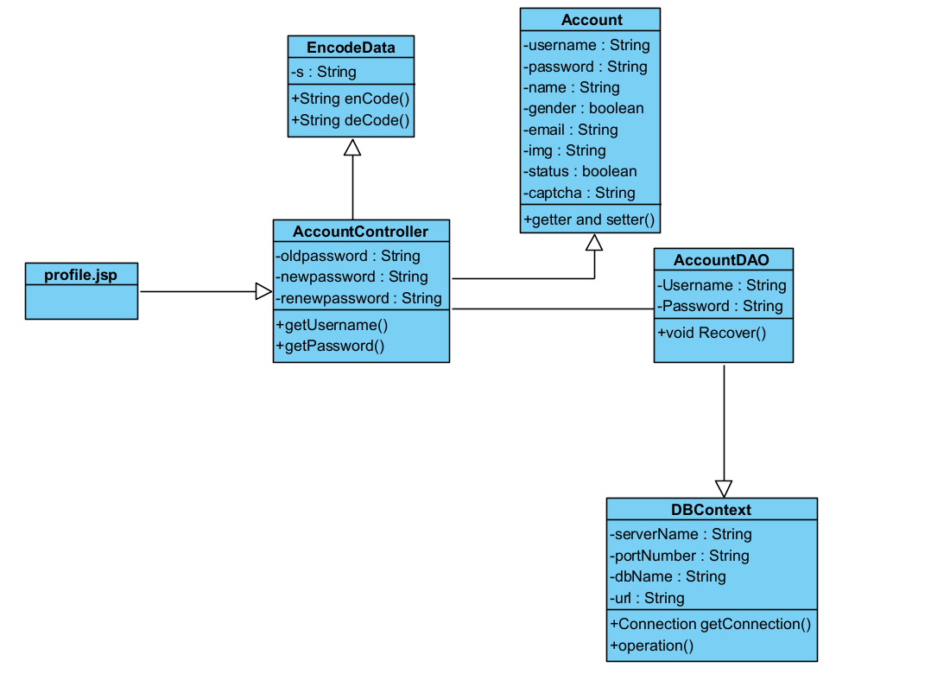

### **b.** **Class Specification**

| No | Method | Description |
| --- | --- | --- |
| 1 | getUsername | using to get username from database throw “Recover” method in Account |
| 2 | enCode | This method takes a string 's' as input and returns the encoded string. |
| 3 | deCode | This method takes a string 's' as input and returns the decoded string. |
| 4 | Recover | Method named ‘Recover‘ that is used to update the password of a user in a database. |

### **c.** **Sequence Diagram**

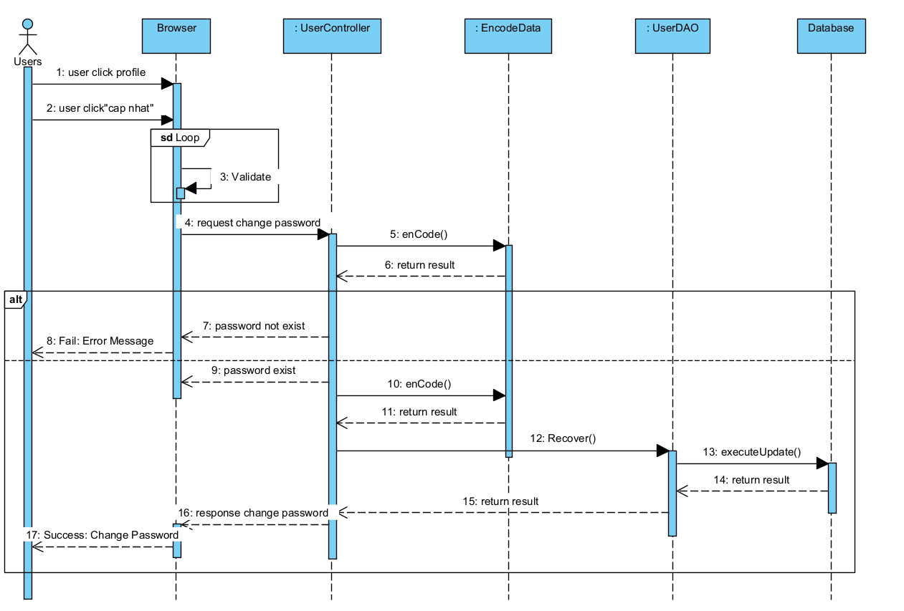

### **d.** **Database queries**

| No | Method | Database queries |
| --- | --- | --- |
| 1 | Recover() | UPDATE `doctris_system`.`users` SET `password` = ? WHERE (`username` = ?) |

## **4. Common Feature/ User profile**

### **a.** **Class Diagram**

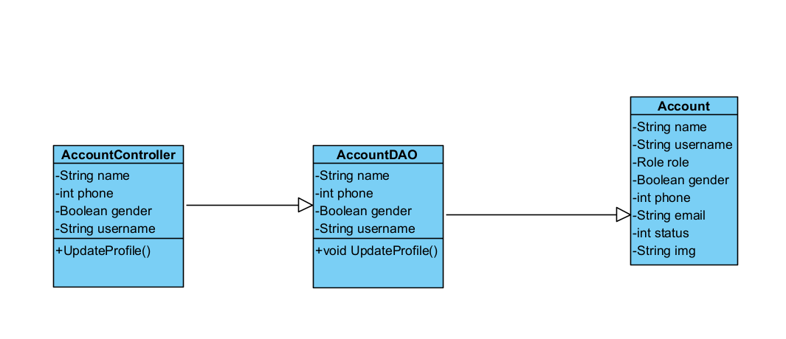

### **b.** **Class Specification**

| No | Method | Description |
| --- | --- | --- |
| 1 | UpdateProfile | use to update user’s profile |

### **c.** **Sequence Diagram**

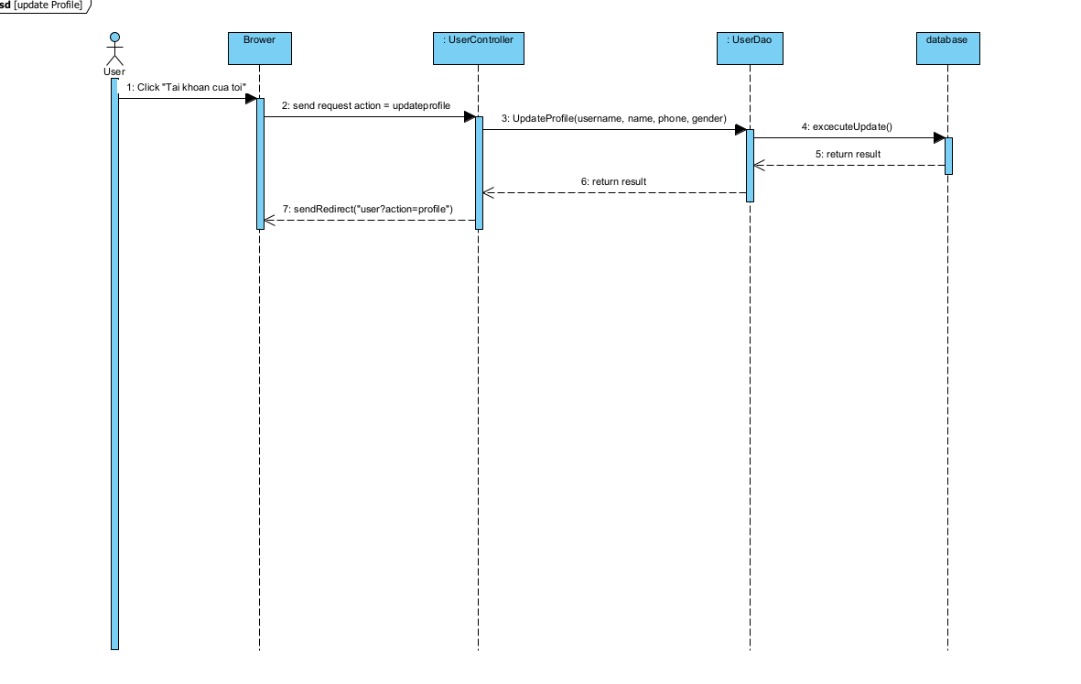

### **d.** **Database queries**

| No | Method | Database Queries |
| --- | --- | --- |
| 1 | UpdateProfile | * UPDATE `doctris_system`.`users` SET `name` = ?, `phone` = ?, `gender` = ? WHERE (`username` = ?) |

## **5. Public Feature/Web Blog List**

### **a. Class Diagram**

### 

### **b.** **Class Specification**

| No | Method | Description |
| --- | --- | --- |
| 1 | getBlogs | get all blog in database order by date |
| 2 | getCategories | get all categories in database |
| 3 | getBlog | get blog by blog id |
| 4 | getBlogBy Featured | get blog which featured |
| 5 | search | get blog that having or contain keyword in its title |
| 6 | getBlogByCategory | get blog in the same category |

### **c. Sequence Diagram**

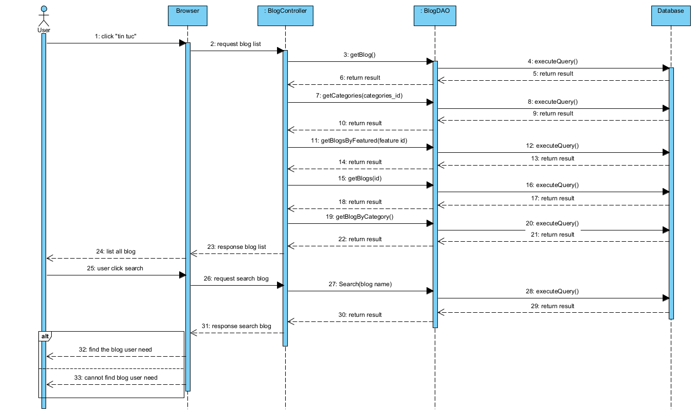

### **d.** **Database queries**

| No | Method | Database Queries |
| --- | --- | --- |
| 1 | getBlogs | SELECT blog.*, category_blog.name FROM blog  inner join category_blog  on blog.category_id = category_blog.id  order by date desc |
| 2 | getCategories | SELECT blog.*, category_blog.name FROM blog  inner join category_blog  on blog.category_id = category_blog.id  where category_id = ?  order by date desc |
| 3 | getBlog | SELECT blog.*, category_blog.name FROM blog  inner join category_blog  on blog.category_id = category_blog.id  where blog_id = ?  order by date desc |
| 4 | getBlogBy Featured | Select * FROM blog where featured = 1 ; |
| 5 | search | SELECT * FROM blog WHERE title LIKE ? ORDER BY date desc |
| 6 | getBlogByCategory | SELECT * FROM category_blog; |

### 

# 

## **6. Common Feature/Forgot Password**

### **a.** **Class Diagram**

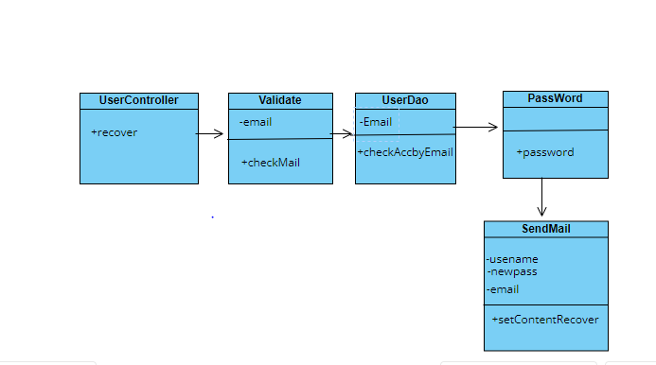

### **b.** **Class Specification**

| No | Method | Description |
| --- | --- | --- |
| 1 | recover | using to forgot password |
| 2 | checkEmail | using to check validate email |
| 3 | checkAccByEmail | using to check exist email |
| 4 | getPassword | using to create password randomrandom |
| 5 | setContentRecover | using to send newpassword |

### **c.** **Sequence Diagram**

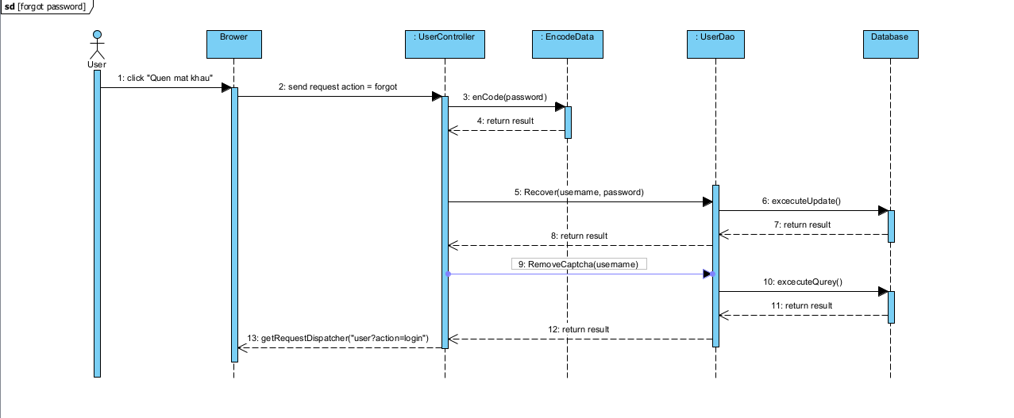

### **d.** **Database queries**

| No | Method | Description |
| --- | --- | --- |
| 1 | recover | String sql = "UPDATE ‘doctris_system’.’users’ SET ‘password’ = ? WHERE (‘username’ = ?)"; |
| 2 | checkAccByEmail | String sql = "SELECT * FROM users where email=?"; |

## **7. Public Feature/Home Page**

### **a.** **Class Diagram**

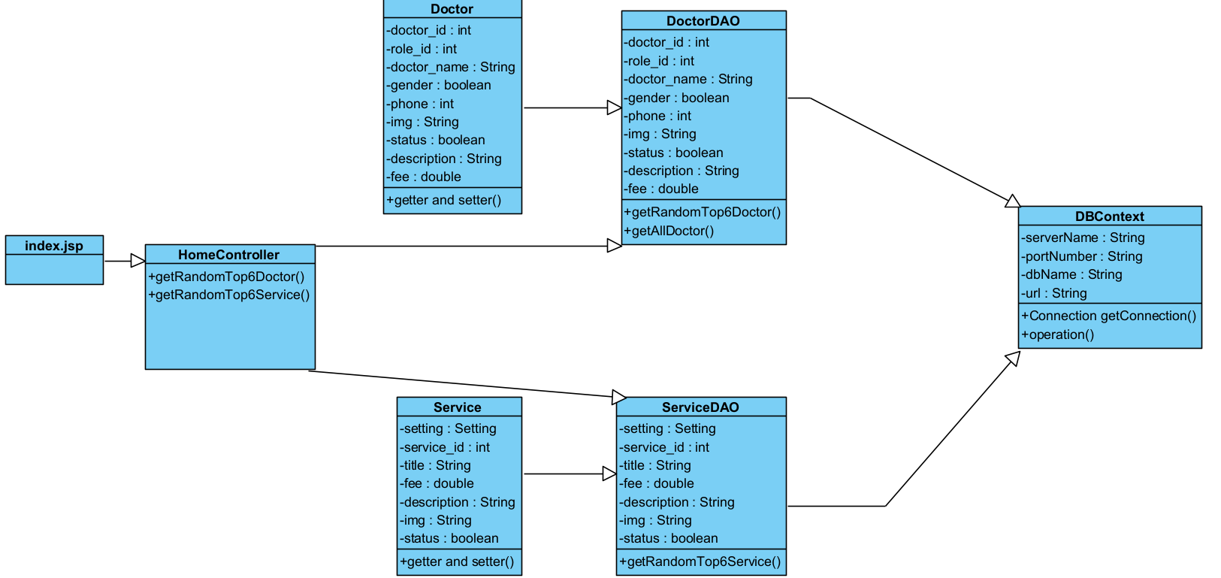

### **b.** **Class Specification**

| No | Method | Description |
| --- | --- | --- |
| 1 | getRandomTop6Doctor | Randomly get information of 8 doctors along with the information of the corresponding service list. |
| 2 | getRandomTop6Service | Randomly get information of 6 services along with the information of the respective specialty list. |

### **c. Sequence Diagram**

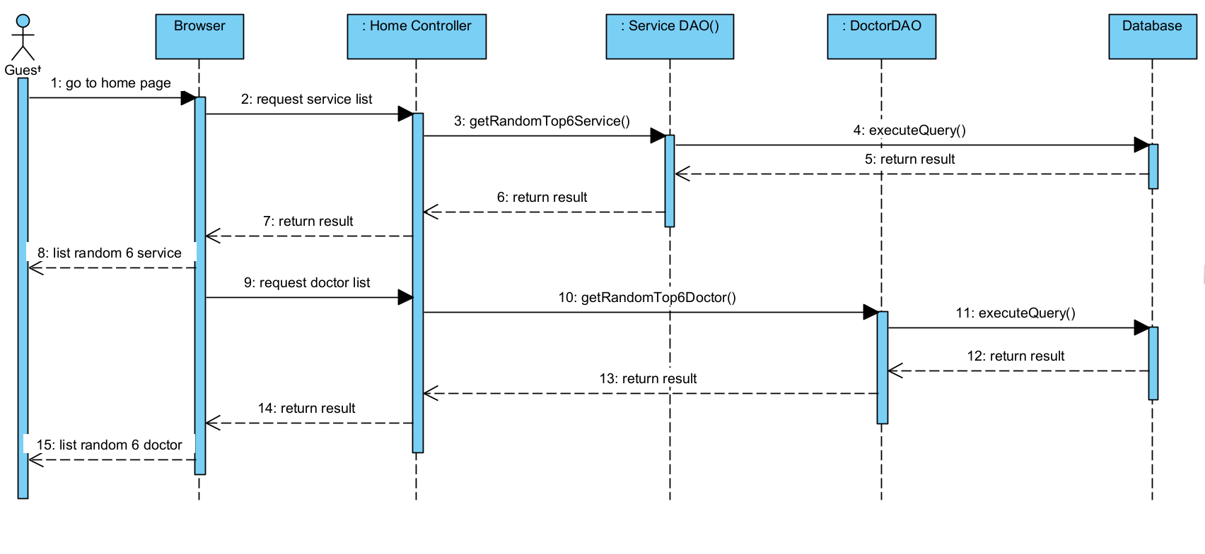

### **d.** **Database queries**

| No | Method | Database queries |
| --- | --- | --- |
| 1 | getRandomTop6Doctor | SELECT concat_ws(cs.id,d.category_id)id, cs.name, cs.setting_id, cs.status, d.doctor_id,d.role_id,d.doctor_name,d.username,  d.gender,d.DOB,d.phone,d.description,d.status,d.img,d.fee,d.position  FROM doctris_system.doctor d INNER JOIN doctris_system.category_service cs  ON d.category_id = cs.id ORDER BY RAND() LIMIT 8 |
| 2 | getRandomTop6Service | SELECT concat_ws(cs.id,s.category_id)id ,cs.name,cs.setting_id,  cs.status,s.service_id,s.title,s.fee,s.description,s.img  FROM doctris_system.service s  INNER JOIN doctris_system.category_service cs  ON s.category_id = cs.id ORDER BY RAND() LIMIT 6 |

## **8. Staff Feature/Doctor List**

### **a.** **Class Diagram**

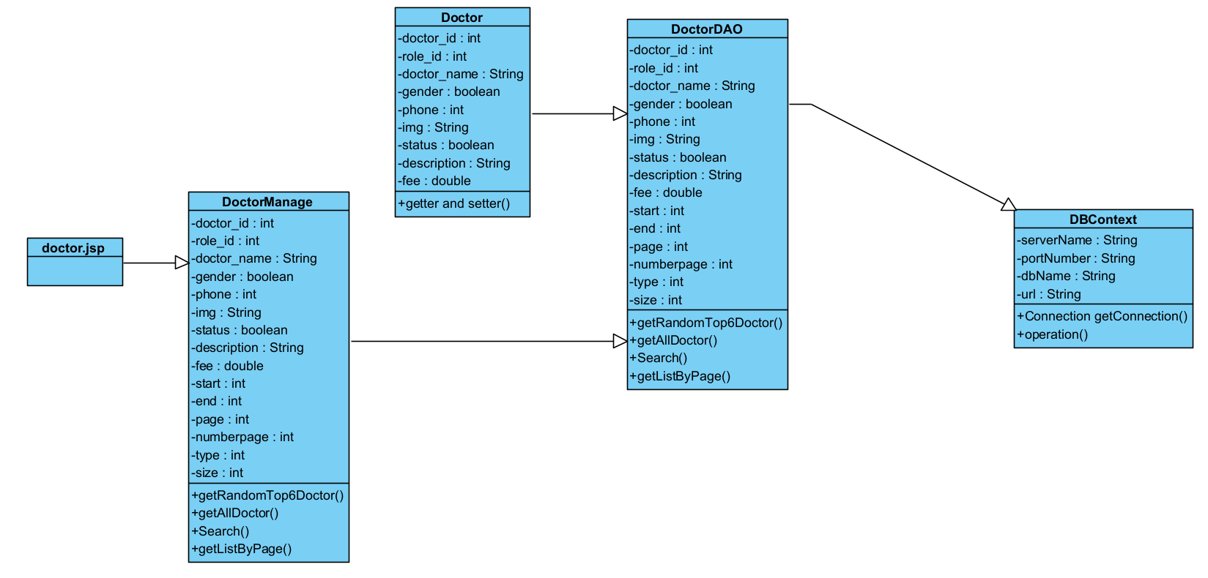

### **b.** **Class Specification**

| No | Method | Database queries |
| --- | --- | --- |
| 1 | getAllDoctor() | List all doctor in database to website throw data query: SELECT cs.name, d.doctor_id,d.doctor_name,d.gender,d.status  FROM doctris_system.doctor d  INNER JOIN doctris_system.category_service cs  ON d.category_id = cs.id |
| 2 | Search() | Search doctor by name throw data query :SELECT cs.name, d.doctor_id,d.doctor_name,d.gender,d.status  FROM doctris_system.doctor d  INNER JOIN doctris_system.category_service cs  ON d.category_id = cs.id WHERE d.doctor_name LIKE ? |
| 3 | getListByPage() | The method getListByPage() above has the function to retrieve a partial list of doctors (Doctor) from a complete list. |

### **c.** **Sequence Diagram**

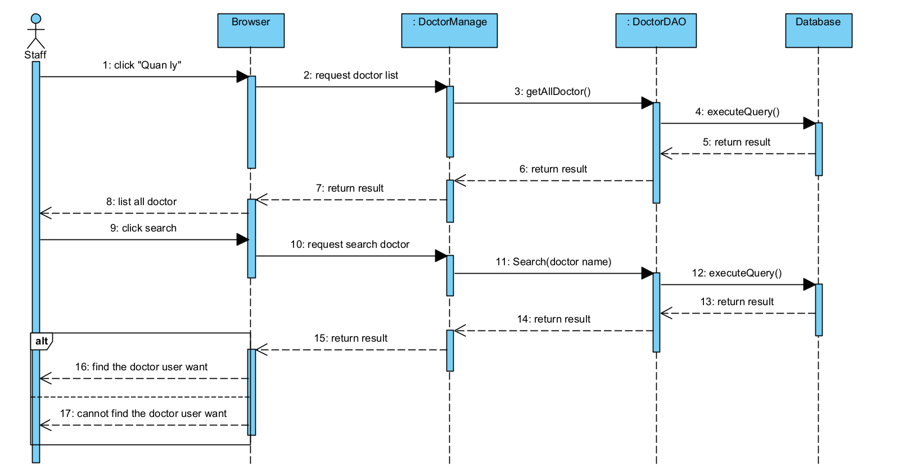

### **d.** **Database queries**

| No | Method | Database queries |
| --- | --- | --- |
| 1 | getAllDoctor() | SELECT cs.name, d.doctor_id,d.doctor_name,d.gender,d.status  FROM doctris_system.doctor d  INNER JOIN doctris_system.category_service cs  ON d.category_id = cs.id |
| 2 | Search() | SELECT cs.name, d.doctor_id,d.doctor_name,d.gender,d.status  FROM doctris_system.doctor d  INNER JOIN doctris_system.category_service cs  ON d.category_id = cs.id WHERE d.doctor_name LIKE ? |

## **9. Public Feature/Web Doctor List**

### **a.** **Class Diagram**

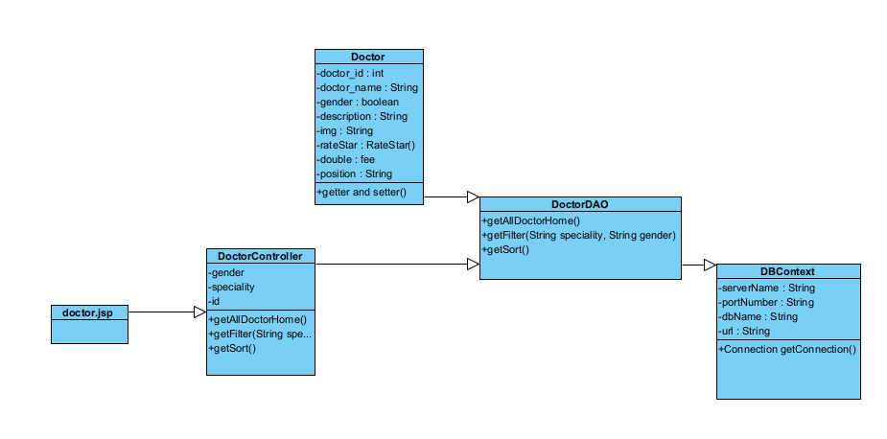

### **b.** **Class Specification**

| No | Method | Description |
| --- | --- | --- |
| 1 | getAllDoctorHome() | used to get information of all doctors from the database. |
| 2 | getFilter(String speciality, String gender) | is used to get a list of doctors based on a filter by specialty (specialty) and gender (gender). |
| 3 | getSort(type) | used to get a list of doctors based on sorting by different criteria (type) |

### 

### **c.** **Sequence Diagram**

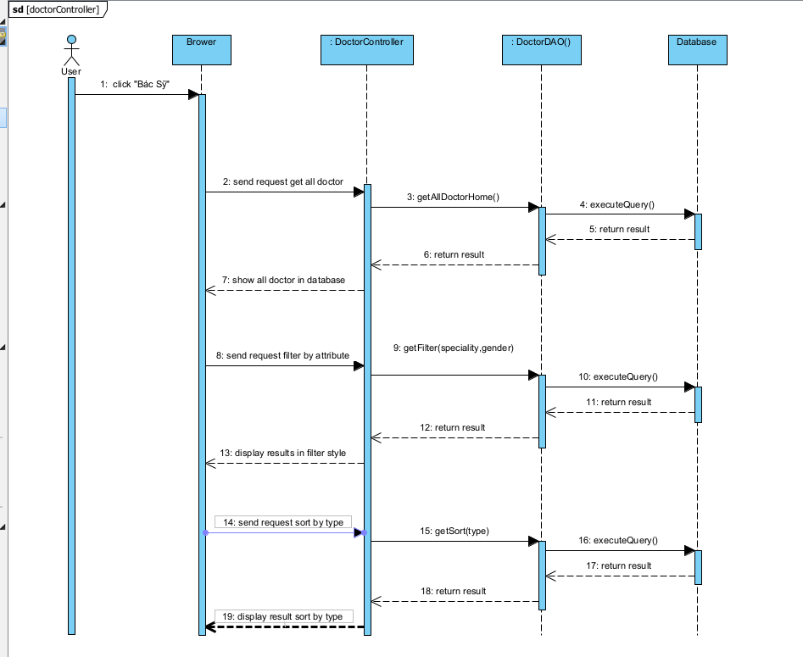

### **d.** **Database queries**

| No | Method | Database queries |
| --- | --- | --- |
| 1 | getAllDoctorHome() | SELECT CONCAT_WS(cs.id, d.category_id) AS id, cs.name, cs.setting_id, cs.status, d.doctor_id, d.role_id, d.doctor_name, d.username, d.gender, d.DOB, d.phone, d.description, d.status, d.img, d.fee, d.position  FROM doctris_system.doctor d  INNER JOIN doctris_system.category_service cs ON d.category_id = cs.id; |
| 2 | getFilter (String speciality, String gender ) | String spec = SELECT CONCAT_WS(cs.id, d.category_id) AS id, cs.name, cs.setting_id, cs.status, d.doctor_id, d.role_id, d.doctor_name, d.username, d.gender, d.DOB, d.phone, d.description, d.status, d.img, d.fee, d.position  FROM doctris_system.doctor d  INNER JOIN doctris_system.category_service cs ON d.category_id = cs.id  WHERE d.category_id = ?;  String gen = SELECT CONCAT_WS( cs.id, d.category_id) AS id, cs.name, cs.setting_id, cs.status, d.doctor_id, d.role_id, d.doctor_name, d.username, d.gender, d.DOB, d.phone, d.description, d.status, d.img, d.fee, d.position  FROM doctris_system.doctor d  INNER JOIN doctris_system.category_service cs ON d.category_id = cs.id  WHERE d.gender = ?;  String filter = SELECT CONCAT_WS(cs.id, d.category_id) AS id, cs.name, cs.setting_id, cs.status, d.doctor_id, d.role_id, d.doctor_name, d.username, d.gender, d.DOB, d.phone, d.description, d.status, d.img, d.fee, d.position  FROM doctris_system.doctor d  INNER JOIN doctris_system.category_service cs ON d.category_id = cs.id  WHERE d.gender = ? AND d.category_id = ?; |
|  | getSort(type) | String star = SELECT CONCAT_WS( cs.id, d.category_id) AS id, cs.name, cs.setting_id, cs.status, d.doctor_id, d.role_id, d.doctor_name, d.username, d.gender, d.DOB, d.phone, d.description, d.status, d.img, d.fee, d.position, SUM(ratestar.star) / COUNT(ratestar.star) AS star  FROM doctris_system.doctor d  INNER JOIN doctris_system.category_service cs ON d.category_id = cs.id  LEFT JOIN ratestar ON d.doctor_id = ratestar.doctor_id  GROUP BY id, cs.name, cs.setting_id, cs.status, d.doctor_id, d.role_id, d.doctor_name, d.username, d.gender, d.DOB, d.phone, d.description, d.status, d.img, d.fee, d.position  ORDER BY star DESC;  String lastest = SELECT CONCAT_WS(cs.id, d.category_id) AS id, cs.name, cs.setting_id, cs.status, d.doctor_id, d.role_id, d.doctor_name, d.username, d.gender, d.DOB, d.phone, d.description, d.status, d.img, d.fee, d.position  FROM doctris_system.doctor d  INNER JOIN doctris_system.category_service cs ON d.category_id = cs.id  ORDER BY d.doctor_id DESC;  String popular = SELECT CONCAT_WS( cs.id, d.category_id) AS id, cs.name, cs.setting_id, cs.status, d.doctor_id, d.role_id, d.doctor_name, d.username, d.gender, d.DOB, d.phone, d.description, d.status, d.img, d.fee, d.position, COUNT(appointments.appointment_id) AS appointment  FROM doctris_system.doctor d  INNER JOIN doctris_system.category_service cs ON d.category_id = cs.id  LEFT JOIN appointments ON d.doctor_id = appointments.doctor_id  GROUP BY id, cs.name, cs.setting_id, cs.status, d.doctor_id, d.role_id, d.doctor_name, d.username, d.gender, d.DOB, d.phone, d.description, d.status, d.img, d.fee, d.position  ORDER BY appointment DESC;  String fee = SELECT CONCAT_WS( cs.id, d.category_id) AS id, cs.name, cs.setting_id, cs.status, d.doctor_id, d.role_id, d.doctor_name, d.username, d.gender, d.DOB, d.phone, d.description, d.status, d.img, d.fee, d.position  FROM doctris_system.doctor d  INNER JOIN doctris_system.category_service cs ON d.category_id = cs.id  ORDER BY d.doctor_id DESC;  String ascending = SELECT CONCAT_WS(cs.id, d.category_id) AS id, cs.name, cs.setting_id, cs.status, d.doctor_id, d.role_id, d.doctor_name, d.username, d.gender, d.DOB, d.phone, d.description, d.status, d.img, d.fee, d.position  FROM doctris_system.doctor d  INNER JOIN doctris_system.category_service cs ON d.category_id = cs.id  ORDER BY d.doctor_id DESC;  String decrease = SELECT CONCAT_WS(cs.id, d.category_id) AS id, cs.name, cs.setting_id, cs.status, d.doctor_id, d.role_id, d.doctor_name, d.username, d.gender, d.DOB, d.phone, d.description, d.status, d.img, d.fee, d.position  FROM doctris_system.doctor d  INNER JOIN doctris_system.category_service cs ON d.category_id = cs.id  ORDER BY d.doctor_id ASC; |

## **10. Public Feature/Web Doctor Detail**

### **a.** **Class Diagram**

## 

### **b.** **Class Specification**

| No | Method | Description |
| --- | --- | --- |
| 1 | getDetail(int id) | used to get a doctor's details based on that doctor's ID. |
| 2 | getRateDoctor(int id) | used to retrieve the ratings and feedback given by users for a specific doctor. |
| 3 | getStars(int id) | used to calculate and retrieve the average star rating for a specific doctor. |
| 44 | CountFeedback(int id) | used to count the number of feedback entries for a specific doctor. |

### 

### **c.** **Sequence Diagram**

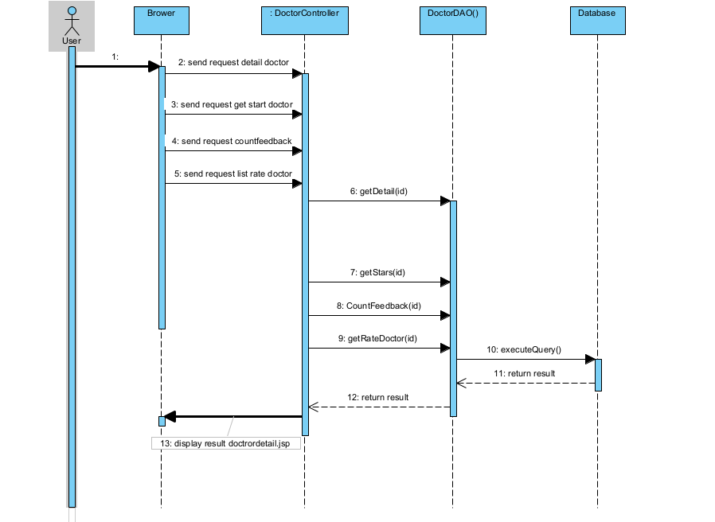

### **d.** **Database queries**

| No | Method | Database queries |
| --- | --- | --- |
| 1 | getDetail(int id) | SELECT CONCAT_WS(cs.id, d.category_id) AS id, cs.name, cs.setting_id, cs.status, d.doctor_id, d.role_id, d.doctor_name, d.username, d.gender, d.DOB, d.phone, d.description, d.status, d.img, d.fee, d.position  FROM doctris_system.doctor d  INNER JOIN doctris_system.category_service cs ON d.category_id = cs.id  WHERE d.doctor_id = ? |
| 2 | getRateDoctor(int id) | SELECT users.name, users.img, ratestar.star, ratestar.feedback, ratestar.datetime  FROM ratestar  INNER JOIN users ON ratestar.username = users.username  WHERE ratestar.doctor_id = ?  ORDER BY ratestar.id DESC |
| 3 | getStars(int id) | SELECT (SUM(star) / COUNT(*)) as star from ratestar where doctor_id = ? |
| 4 | CountFeedback(int id) | SELECT COUNT(*) from ratestar where doctor_id = ? |

## 

## **11.Public Feature/Web Service List**

### **a.** **Class Diagram**

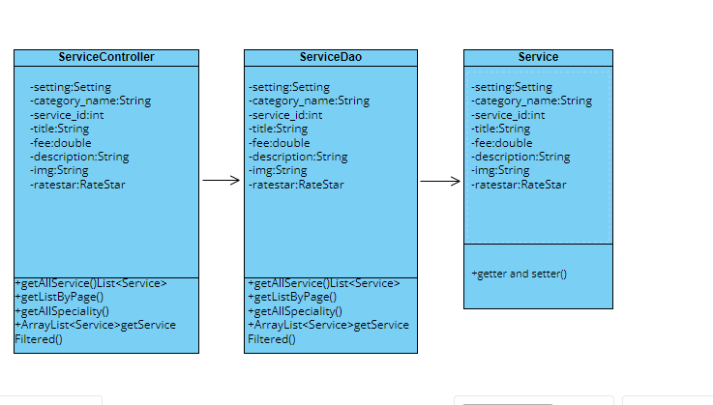

### **b.** **Class Specification**

| No | Method | Description |
| --- | --- | --- |
| 1 | getAllService | use to list Services |
| 2 | getServiceById | use to find Service by Id |
| 3 | getListByPage | use to pagination |
| 4 | getAllSpeciality | use to list Speciality |

### **c.** **Sequence Diagram**

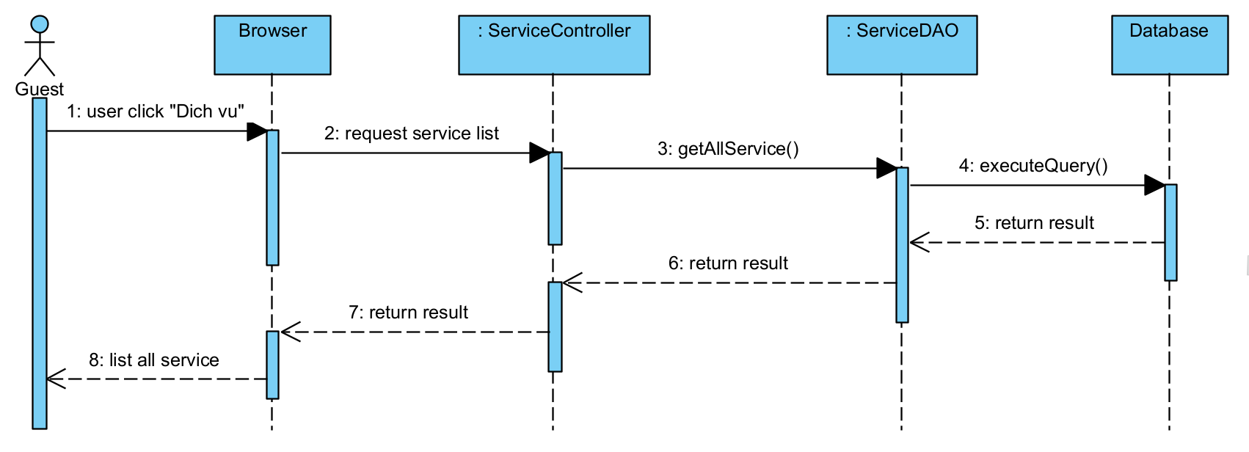

### **d.** **Database queries**

| No | Method | Database Queries |
| --- | --- | --- |
| 1 | getAllService | SELECT s.title, cs.name, sum(r.star)/count(r.star), count(r.feedback), s.fee, s.description, s.service_id FROM doctris_system.service s  left join doctris_system.ratestar r  on s.service_id = r.service_id  inner join doctris_system.category_service cs  on cs.id = s.category_id  group by s.title, cs.name, s.fee, s.description, s.service_id |
| 2 | getServiceById | SELECT s.title, cs.name, sum(r.star)/count(r.star), count(r.feedback), s.fee, s.description, s.service_id FROM doctris_system.service s  left join doctris_system.ratestar r  on s.service_id = r.service_id  inner join doctris_system.category_service cs  on cs.id = s.category_id  group by s.title, cs.name, s.fee, s.description, s.service_id  Having s.service_id = ? |
| 4 | getAllSpeciality | SELECT cs.name, cs.id FROM doctris_system.service s  inner join doctris_system.category_service cs  on cs.id = s.category_id  group by cs.name, cs.id |

## **12. Doctor Feature/Patient’s doctor**

### **a.** **Class Diagram**

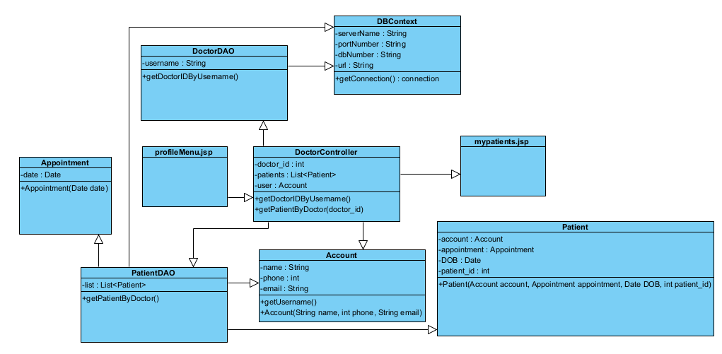

### **b.** **Class Specification**

| No | Method | Description |
| --- | --- | --- |
| 1 | getDoctorIDByUsername | Get the doctor's id with the username passed in. |
| 2 | getUsername | get the passed username. |
| 3 | getPatientByDoctor | Retrieve the patients from the passed in doctor's id. |
| 4 | getConnection | using to connect Database. |

### **c.** **Sequence Diagram**

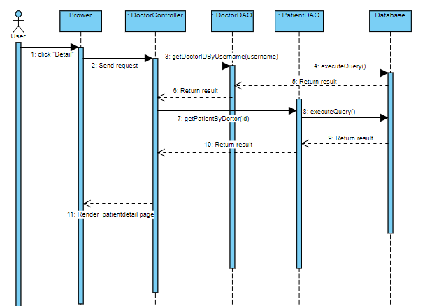

### **d.** **Database queries**

| No | Method | Database queries |
| --- | --- | --- |
| 1  2 | getDoctorIDByUsername(String usename)  getPatientByDoctor(int doctor_id) | select doctor_id from doctor where username = ?  select distinct users.name, users.phone, users.email, a.pdate, patient.DOB, patient.patient_id  as lastbooking from appointments  inner join patient on appointments.patient_id = patient.patient_id  inner join users on patient.username = users.username inner join  (select patient_id as pid , max(date) as pdate from appointments group by patient_id)  as a on a.pid = appointments.patient_id where appointments.doctor_id = ? |

## **13. Doctor Feature/Patient detail**

### **a.** **Class Diagram**

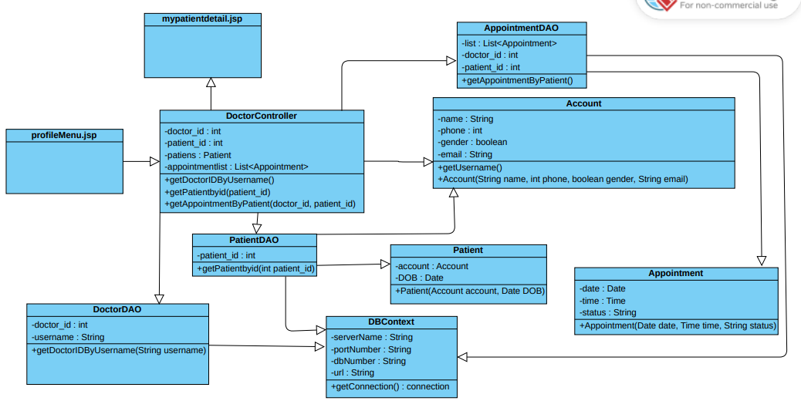

### **b.** **Class Specification**

| No | Method | Description |
| --- | --- | --- |
| 1 | getDoctorIDByUsername() | Get the doctor's id with the username passed in. |
| 2 | getPatientbyid() | Get patient information from passed id |
| 3 | getAppointmentByPatient() | Retrieve appointments from passed in doctor id and patient id |
| 4 | getConnection() | using to connect Database. |

### **c.** **Sequence Diagram**

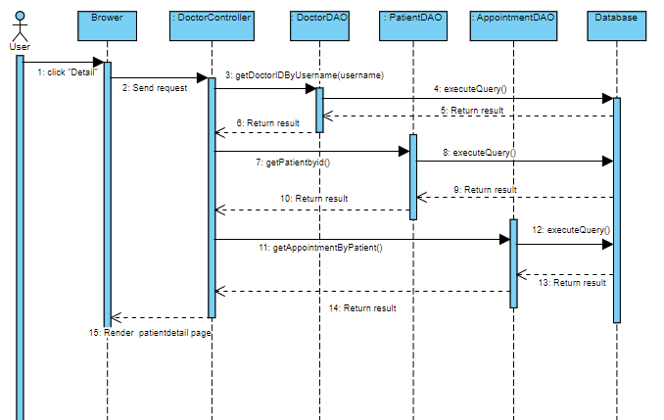

### **d.** **Database queries**

| No | Method | Database queries |
| --- | --- | --- |
| 1  2 | getDoctorIDByUsername(String username)  Patient getPatientbyid(int patient_id) | select doctor_id from doctor where username = ?  SELECT u.name,u.email,u.phone,u.gender,p.DOB FROM users u inner join patient p on u.username = p.username where p.patient_id = ? |
| 3 | getAppointmentByPatient(int doctor_id, int patient_id) | select a.date,a.time,a.status from appointments a inner join patient p on a.patient_id = p.patient_id where a.doctor_id = ? and p.patient_id = ? ORDER BY a.date ASC |

## 

## **14 Doctor Feature/My appointment**

### **a.** **Class Diagram**

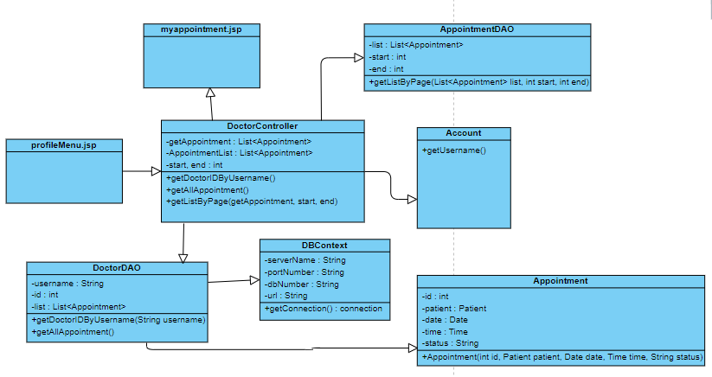

### **b.** **Class Specification**

| No | Method | Description |
| --- | --- | --- |
| 1 | getDoctorIDByUsername() | Get the doctor's id with the username passed in. |
| 2 | getAllAppointment() | Retrieve appointments with passed in doctor id |
| 3 | getListByPage() | Get a list of pages |
| 4 | getConnection() | using to connect Database. |

### **c.** **Sequence Diagram**

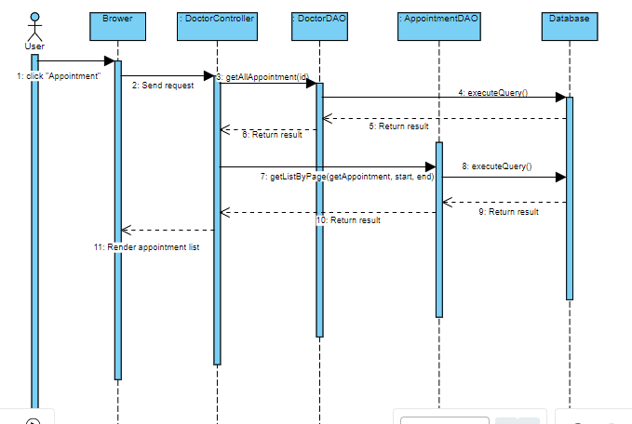

### **d.** **Database queries**

| No | Method | Database queries |
| --- | --- | --- |
| 1 | getDoctorIDByUsername(String username) | select doctor_id from doctor where username = ? |
| 2 | getAllAppointment(int id) | SELECT a.appointment_id, p.patient_id, u.name, a.date, a.time, a.status from appointments a  INNER JOIN patient p ON a.patient_id = p.patient_id  INNER JOIN users u ON p.username = u.username  WHERE a.doctor_id = '19'  group by a.appointment_id, p.patient_id, u.name,a.date, a.time,a.status  order by CAST(a.date AS DATETIME) + CAST(a.time AS DATETIME) desc |

## **15. Doctor Feature/My appointment Details**

### **a.** **Class Diagram**

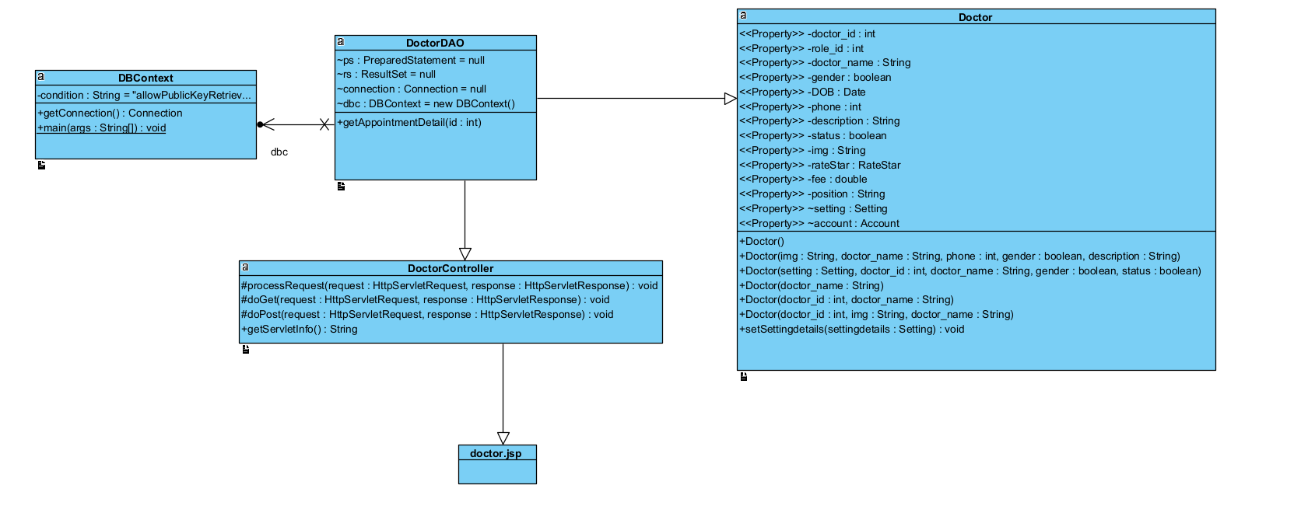

### **b.** **Class Specification**

| No | Method | Description |
| --- | --- | --- |
| 1 | getAppointmentDetail() | to get detailed information of an Appointment |

### **c.** **Sequence Diagram**

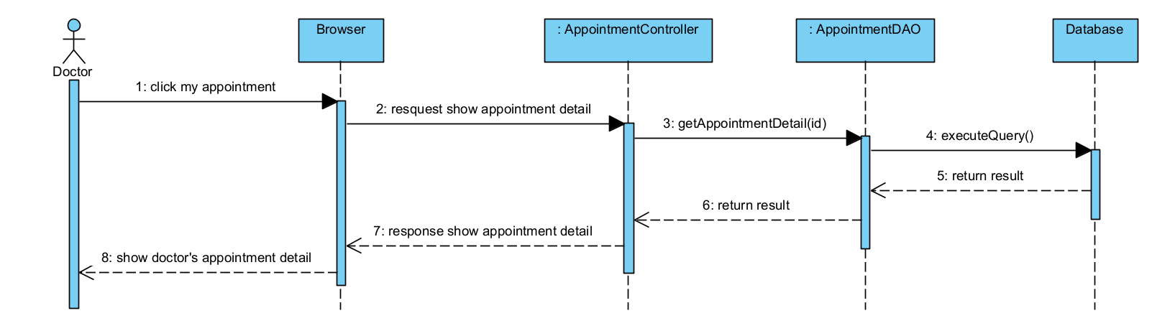

### **d.** **Database queries**

| No | Method | Database Queries |
| --- | --- | --- |
| 1 | getAppointmentDetail() | SELECT a.appointment_id, p.patient_id, u.name,a.date, a.time,a.status from appointments a  INNER JOIN patient p  ON a.patient_id = p.patient_id  INNER JOIN users u  ON p.username = u.username  WHERE a.appointment_id = ? |

## **16. Doctor Feature/My Feedback**

### **a.** **Class Diagram**

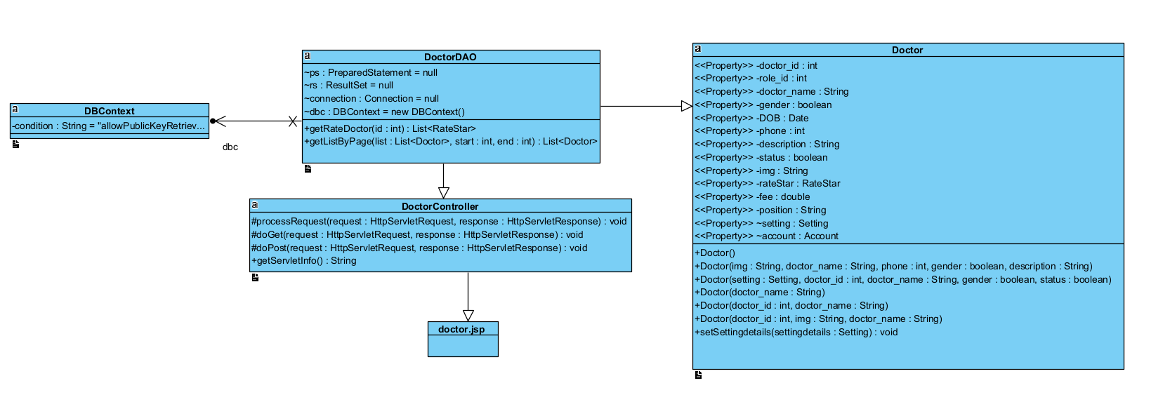

### **b.** **Class Specification**

| No | Method | Description |
| --- | --- | --- |
| 1 | getRateDoctor() | show feedback of doctor |
| 2 | getListByPageRate() | pagination feedback |

### **c.** **Sequence Diagram**

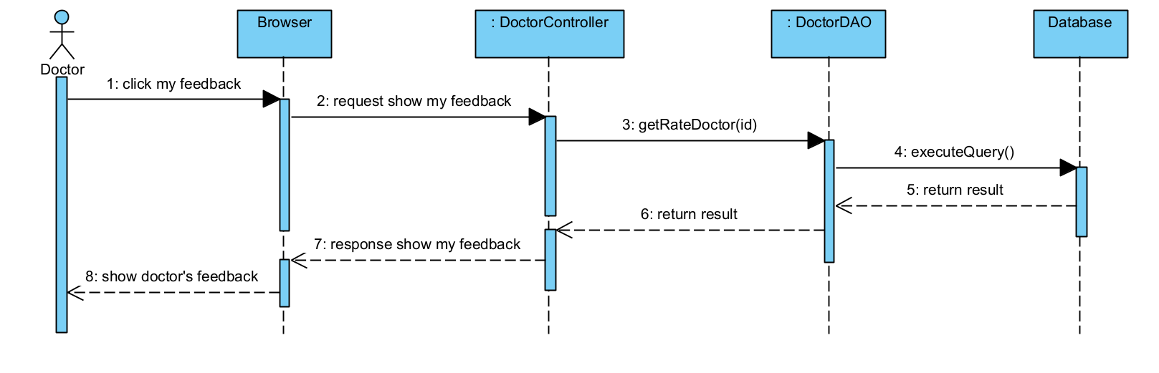

### **d.** **Database queries**

| No | Method | Database queries |
| --- | --- | --- |
| 1 | getRateDoctor() | String sql = "SELECT users.name, users.img, ratestar.star, ratestar.feedback, ratestar.datetime FROM ratestar inner join users on ratestar.username = users.username where ratestar.doctor_id = ? order by ratestar.id desc |

## 

## **17. Admin Feature/Dashboard**

### **Class Diagram**

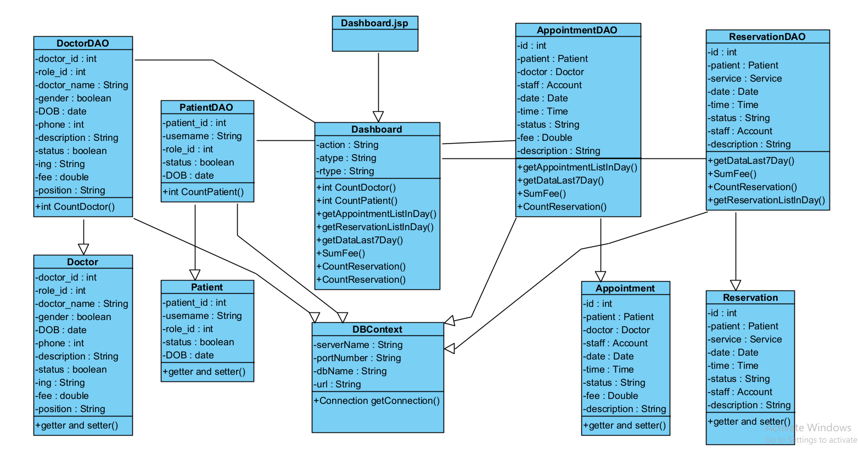

### **Class Specification**

| No | Method | Description |
| --- | --- | --- |
| 1 | getAppointmentListInDay() | Get the doctor's appointment for the day |
| 2 | getReservationListInDay() | Get service appointment of the day |
| 3 | getDataLast7Day() | statistics in 7 days |
| 4 | CountAppointment() | Count the number of appointments in the latest month |
| 5 | CountReservation() | Count the number of service in the latest month |
| 6 | CountPatient() | number of patient active |
| 7 | CountDoctor() | number of doctors active |
| 8 | SumFee() | get total revenue |

### **Sequence Diagram**

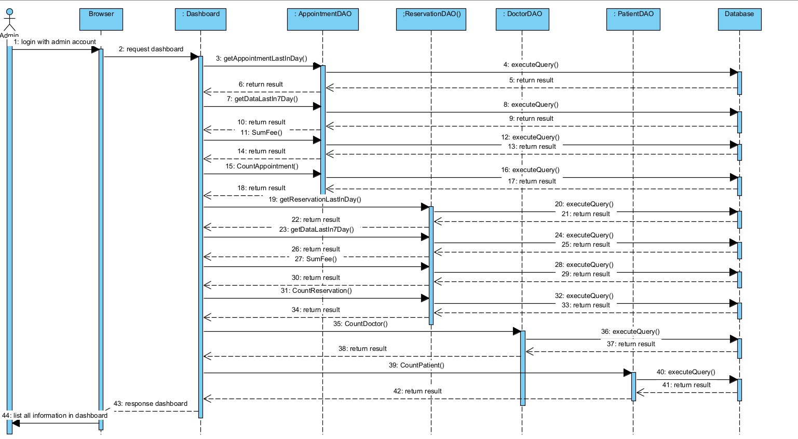

### **Database queries**

| No | Method | Description |
| --- | --- | --- |
| 1 | getAppointmentListInDay | SELECT appointments.appointment_id, doctor.doctor_name, users.name,  appointments.date, appointments.time, appointments.status  FROM appointments  INNER JOIN doctor ON appointments.doctor_id = doctor.doctor_id  INNER JOIN patient ON appointments.patient_id = patient.patient_id  INNER JOIN users ON patient.username = users.username  WHERE DATE(appointments.date) = CURDATE(); |
| 2 | getReservationListInDay | SELECT reservations.reservation_id, users.name, service.title,  reservations.date, reservations.time, reservations.status  FROM reservations  INNER JOIN service ON reservations.service_id = service.service_id  INNER JOIN patient ON reservations.patient_id = patient.patient_id  INNER JOIN users ON patient.username = users.username  WHERE reservations.date = CAST(CURDATE() AS DATE); |
| 3 | getDataLast7Day | SELECT p.day, COALESCE(COUNT(u.reservation_id), 0) AS count  FROM (  SELECT CURDATE() AS day  UNION  SELECT DATE_SUB(CURDATE(), INTERVAL 1 DAY)  UNION  SELECT DATE_SUB(CURDATE(), INTERVAL 2 DAY)  UNION  SELECT DATE_SUB(CURDATE(), INTERVAL 3 DAY)  UNION  SELECT DATE_SUB(CURDATE(), INTERVAL 4 DAY)  UNION  SELECT DATE_SUB(CURDATE(), INTERVAL 5 DAY)  UNION  SELECT DATE_SUB(CURDATE(), INTERVAL 6 DAY)  ) AS p  LEFT JOIN reservations AS u ON p.day = u.date  GROUP BY p.day  ORDER BY p.day ASC; |
| 4 | CountAppointment | select count(*) from appointments where status = 'Complete' AND month(appointments.date) = month(CURRENT_DATE) |
| 5 | CountReservation | select count(*) from reservations where reservations.status = 'Complete' AND month(reservations.date) = month(CURRENT_DATE) |
| 6 | CountPatient | select count(*) from patient |
| 7 | CountDoctor | select count(*) from doctor |
| 8 | SumFee | select sum(fee) from appointments where status = 'Complete' AND month(appointments.date) = month(CURRENT_DATE) |

## **18. Admin Feature/Setting List**

### **a.** **Class Diagram**

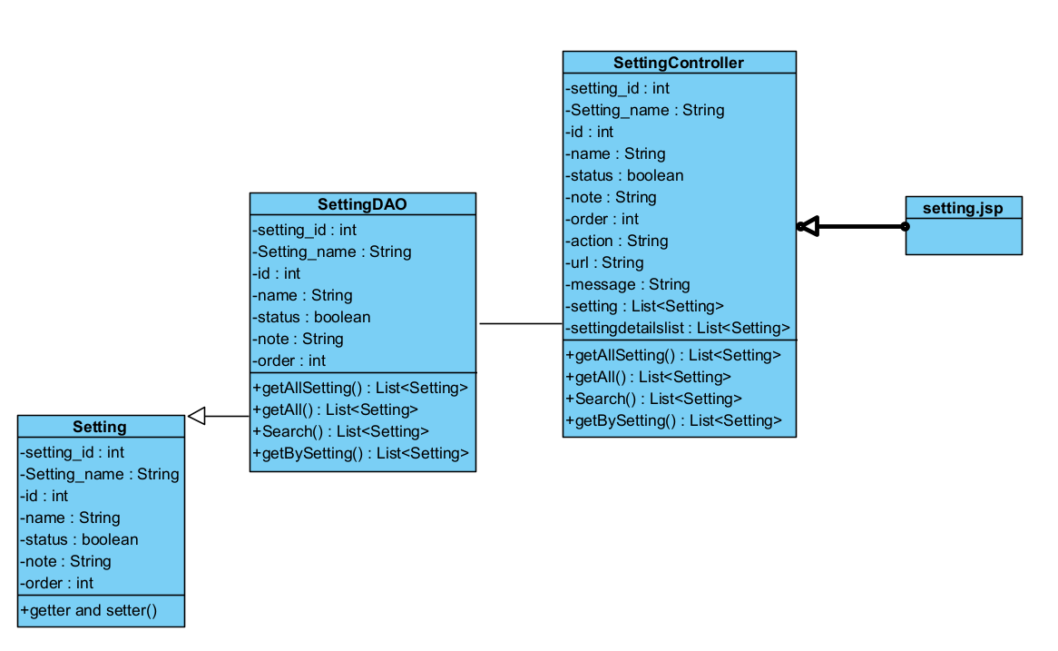

### 

### **b.** **Class Specification**

| No | Method | Description |
| --- | --- | --- |
| 1 | getAllSetting | use to list setting |
| 2 | getListByPage | use to pagination |
| 3 | Search | Search setting |
| 4 | getBySetting | Filter table |

### **c.** **Sequence Diagram**

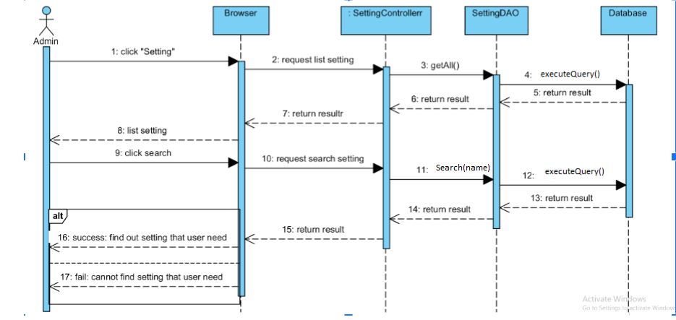

### **d.** **Database queries**

| No | Method | Description |
| --- | --- | --- |
| 1 | getAll | SELECT * FROM doctris_system.role  UNION  SELECT * FROM doctris_system.category_blog  UNION  SELECT * FROM doctris_system.category_service; |
| 3 | Search | SELECT *  FROM doctris_system.role r  WHERE r.id LIKE '%"+search+"%' OR r.name LIKE '%"+search+"%' OR r.setting_id LIKE '%"+search+"%' OR r.order LIKE '%"+search+"%' OR r.note LIKE '%"+search+"%' OR r.status LIKE '%"+search+"%'  UNION  SELECT *  FROM doctris_system.category_blog b  WHERE b.id LIKE '%"+search+"%' OR b.name LIKE '%"+search+"%' OR b.setting_id LIKE '%"+search+"%' OR b.order LIKE '%"+search+"%' OR b.note LIKE '%"+search+"%' OR b.status LIKE '%"+search+"%'  UNION  SELECT *  FROM doctris_system.category_service s  WHERE s.id LIKE '%"+search+"%' OR s.name LIKE '%"+search+"%' OR s.setting_id LIKE '%"+search+"%' OR s.order LIKE '%"+search+"%' OR s.note LIKE '%"+search+"%' OR s.status LIKE '%"+search+"%'; |
| 4 | getBySetting | select * from " + table |

## **19. Admin Feature/Setting Details**

## **a.** **Class Diagram**

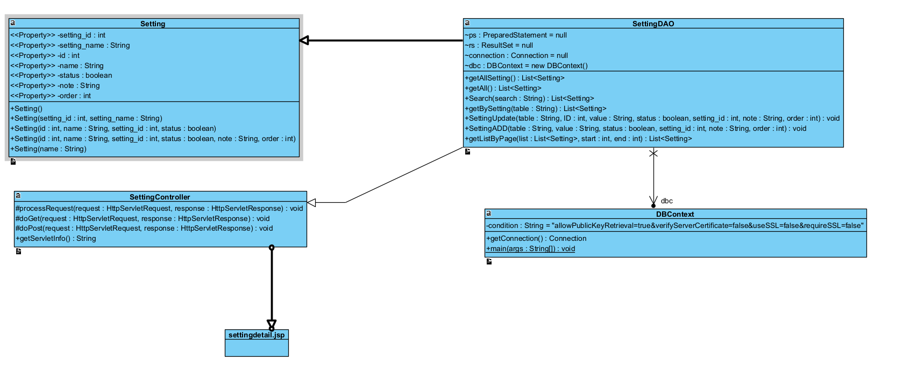

## **b.** **Class Specification**

| No | Method | Description |
| --- | --- | --- |
| 1 | SettingUpdate | use to update setting |

## **c.** **Sequence Diagram**

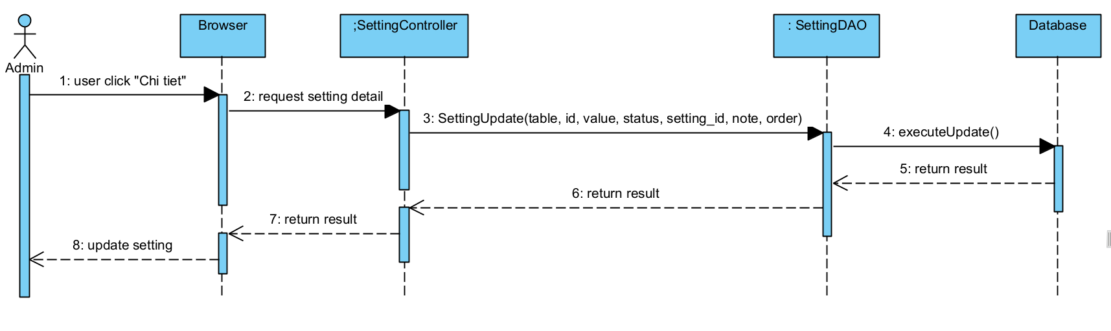

## **d.** **Database queries**

| No | Method | Database queries |
| --- | --- | --- |
| 1 | SettingUpdate | - UPDATE category_blog SET name = ?, setting_id = ?, status = ?, note = ? , r.order = ? WHERE (id = ?)  -UPDATE category_service SET name = ?, setting_id = ?, status = ?, note = ? , r.order = ? WHERE (id = ?)  - UPDATE role SET name = ?, setting_id = ?, status = ?, note = ? , r.order = ? WHERE (id = ?) |

## **20. Admin Feature/Account List**

## **a.** **Class Diagram**

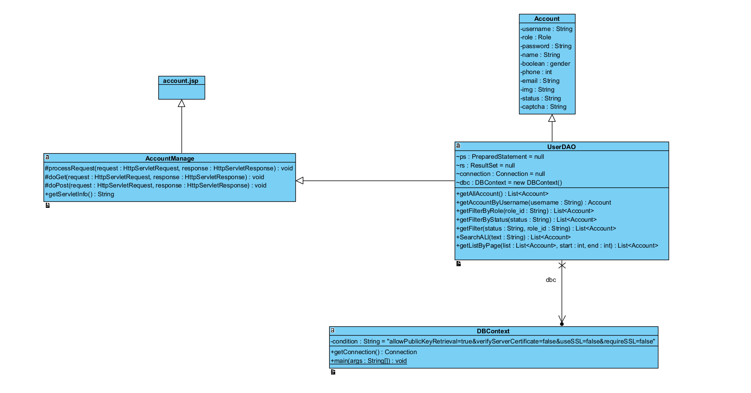

## **b.** **Class Specification**

| No | Method | Description |
| --- | --- | --- |
| 1 | getAllAccount | Show list account of user |
| 2 | getAccountByUseName | Search account by username |
| 3 | getListByPage | Show 8 row in a page |

## **c.** **Sequence Diagram**

Show all account in Account list function

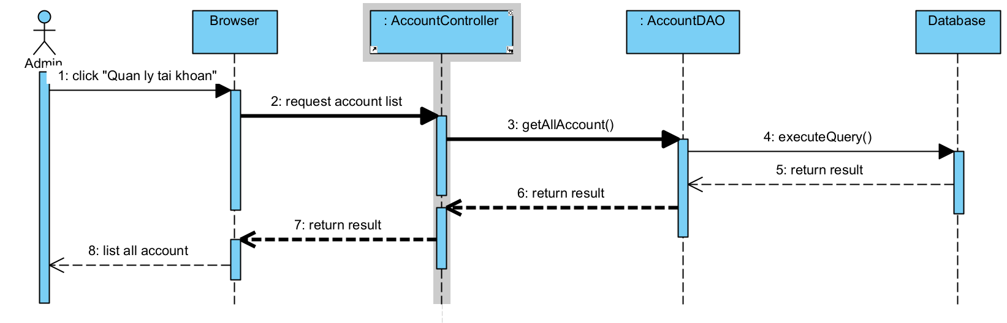

## **d.** **Database queries**

| No | Method | Database queries |
| --- | --- | --- |
| 1 | getAllAccount | SELECT u.username,u.name,u.gender,u.email,u.phone,r.name,u.status,u.img FROM doctris_system.users u inner join doctris_system.role r on u.role_id = r.id |
| 2 | getAccountByUseName | SELECT DISTINCT u.username,u.name,u.gender,u.email,u.phone,r.name,u.status,u.img FROM doctris_system.users u inner join doctris_system.role r on u.role_id = r.id where u.name LIKE ? OR u.email LIKE ? OR u.phone LIKE ? OR u.username LIKE ? |

## **21. Admin Feature/Account Detail**

### **a.** **Class Diagram**

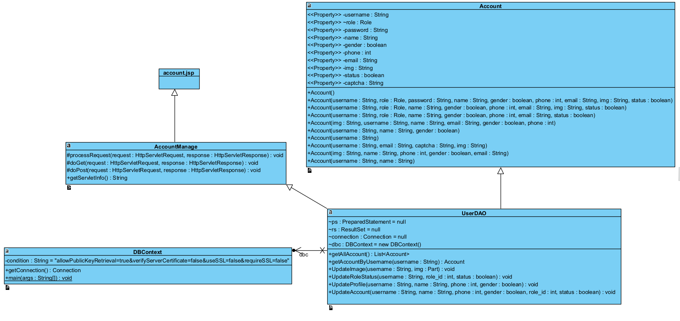

### **b. Class Specification**

| No | Method | Description |
| --- | --- | --- |
| 1 | getAccountByUseName | Search account by username |
| 2 | UpdateImage | Update image of user |
| 3 | Updateprofile | Update profile of user in account detail |

### **c. Sequence Diagram**

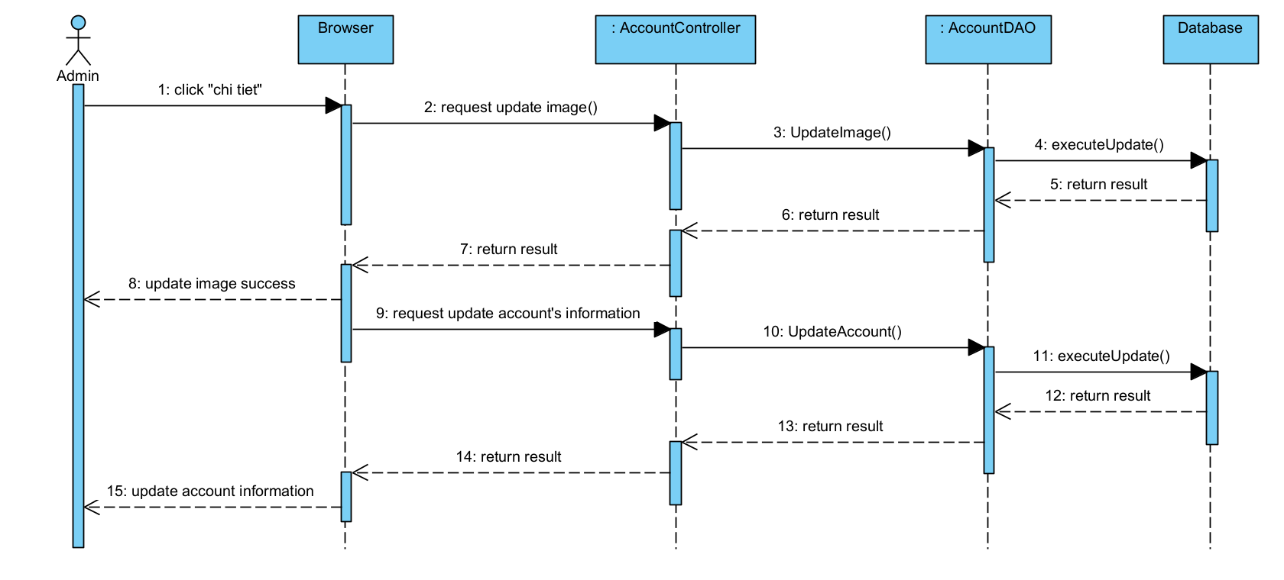

### **d. Database queries**

| No | Method | Database queries |
| --- | --- | --- |
| 1 | getAccountByUseName | SELECT DISTINCT u.username,u.name,u.gender,u.email,u.phone,r.name,u.status,u.img FROM doctris_system.users u inner join doctris_system.role r on u.role_id = r.id where u.name LIKE ? OR u.email LIKE ? OR u.phone LIKE ? OR u.username LIKE ? |
| 2 | UpdateImage | UPDATE `doctris_system`.`users` SET `img` = ? WHERE (`username` = ?) |
| 3 | Updateprofile | UPDATE `doctris_system`.`users` SET `name` = ?, `phone` = ?, `gender` = ? WHERE (`username` = ?) |

## **22. Patient Feature/Book Appointment**

### **a.** **Class Diagram**

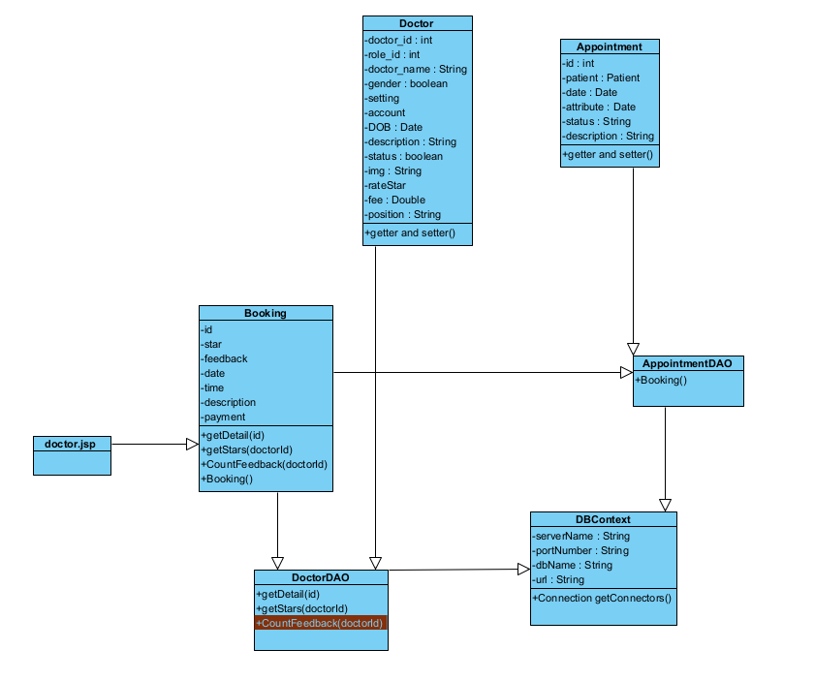

### **b. Class Specification**

| No | Method | Description |
| --- | --- | --- |
| 1 | getDetail(id) | get details of doctor by id from database |
| 2 | getStars(id) | get the rating amount information in star format about the doctor by id from the database |
| 3 | CountFeedback(id) | get information about the number of detailed patient reviews of doctors by id from the database |
| 4 | Booking() | add 1 field value about the information of the scheduler to the appointments table in the database |

### 

### **c. Sequence Diagram**

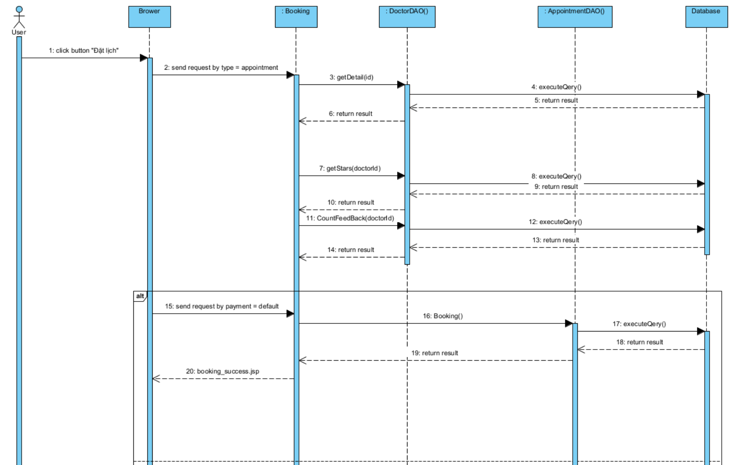

### **d. Database queries**

| No | Method | Database queries |
| --- | --- | --- |
| 1 | getDetail(id) | SELECT CONCAT_WS(cs.id, d.category_id) AS id, cs.name, cs.setting_id, cs.status, d.doctor_id, d.role_id, d.doctor_name, d.username, d.gender, d.DOB, d.phone, d.description, d.status, d.img, d.fee, d.position FROM doctris_system.doctor d INNER JOIN doctris_system.category_service cs ON d.category_id = cs.id WHERE d.doctor_id = ? |
| 2 | getStars(id) | SELECT (SUM(star) / COUNT(*)) as star from ratestar where doctor_id = ? |
| 3 | CountFeedback(id) | SELECT COUNT(*) from ratestar where doctor_id = ? |
| 4 | Booking() | INSERT INTO `reservations` (`patient_id`, `service_id`, `staff`, `date`, `time`, `status`, `description`, `payment`) VALUES (?, ?, ?, STR_TO_DATE(?,'%d/%m/%Y'), ?, ?, ?, ?) |

## 

## **23. Patient Feature/Reserve**

### **a.** **Class Diagram**

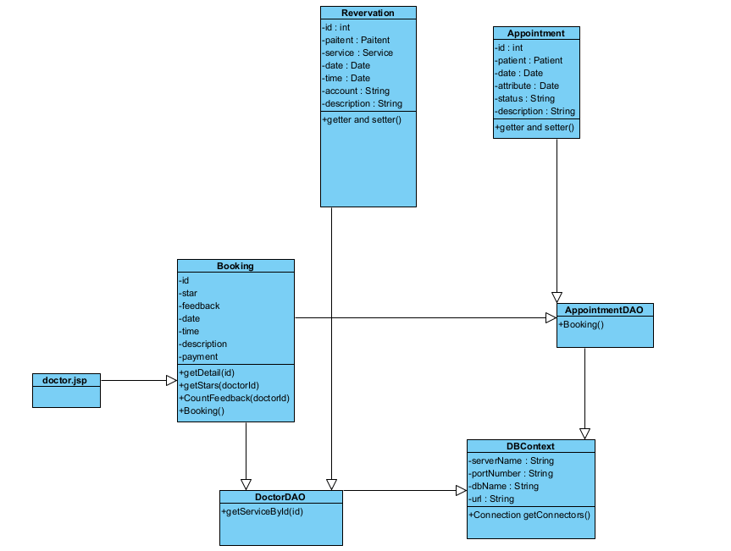

### **b. Class Specification**

| No | Method | Description |
| --- | --- | --- |
| 1 | getServiceById(id) | get details about service information by id from database |
| 22 | Booking() | add 1 field value about the information of the scheduler to the appointments table in the database |

### 

### **c. Sequence Diagram**

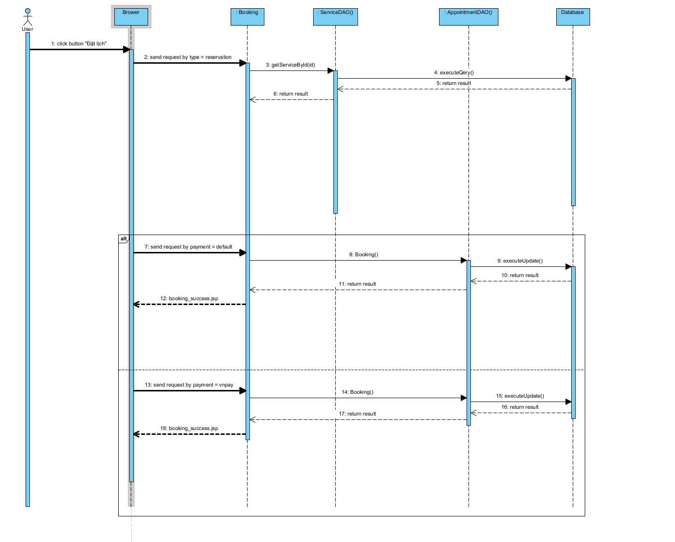

### **d. Database queries**

| No | Method | Database queries |
| --- | --- | --- |
| 1 | getServiceById(id) | SELECT s.title, cs.name, SUM(r.star)/COUNT(r.star), COUNT(r.feedback), s.fee, s.description, s.service_id, s.img FROM doctris_system.service s LEFT JOIN doctris_system.ratestar r ON s.service_id = r.service_id INNER JOIN doctris_system.category_service cs ON cs.id = s.category_id GROUP BY s.title, cs.name, s.fee, s.description, s.service_id HAVING s.service_id = <id> |
| 2 | Booking() | INSERT INTO `reservations` (`patient_id`, `service_id`, `staff`, `date`, `time`, `status`, `description`, `payment`) VALUES (?, ?, ?, STR_TO_DATE(?,'%d/%m/%Y'), ?, ?, ?, ?) |

## **24. Marketing Feature/Service Detail**

### **a.** **Class Diagram**

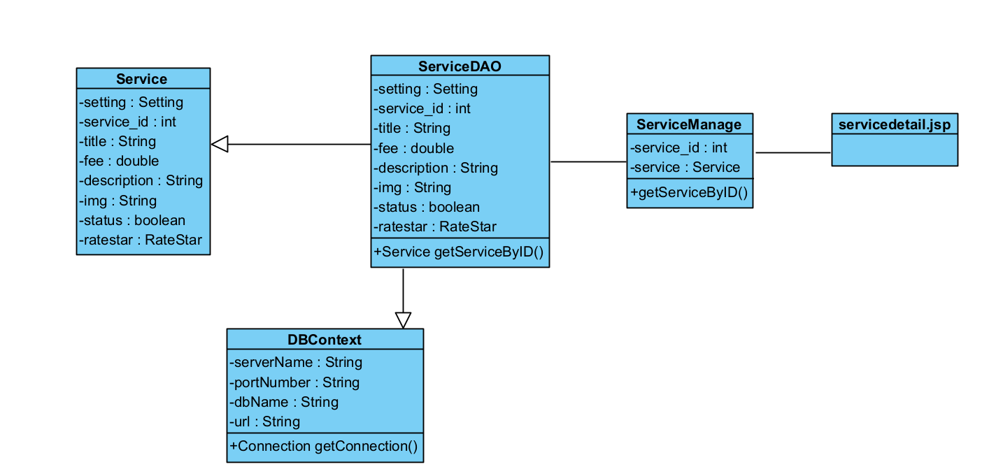

### **b.** **Class Specification**

| No | Method | Description |
| --- | --- | --- |
| 1 | getServiceByID() | Using to view detail service by get service_id throw sql queries: SELECT c.name, s.status, s.service_id, s.title, s.fee, s.description, s.img  FROM service s  INNER JOIN category_service c ON s.category_id = c.id  WHERE s.service_id = ? |

### **c. Sequence Diagram**

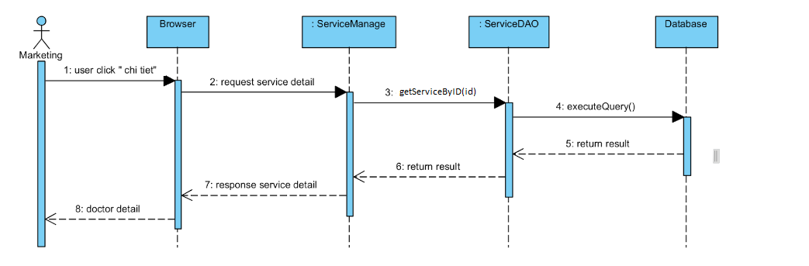

### **d. Database queries**

## 

| No | Method | Description |
| --- | --- | --- |
| 1 | getServiceByID() | SELECT c.name, s.status, s.service_id, s.title, s.fee, s.description, s.img  FROM service s  INNER JOIN category_service c ON s.category_id = c.id  WHERE s.service_id = ? |

## **25. Marketing Feature/Service Add**

### **a.** **Class Diagram**

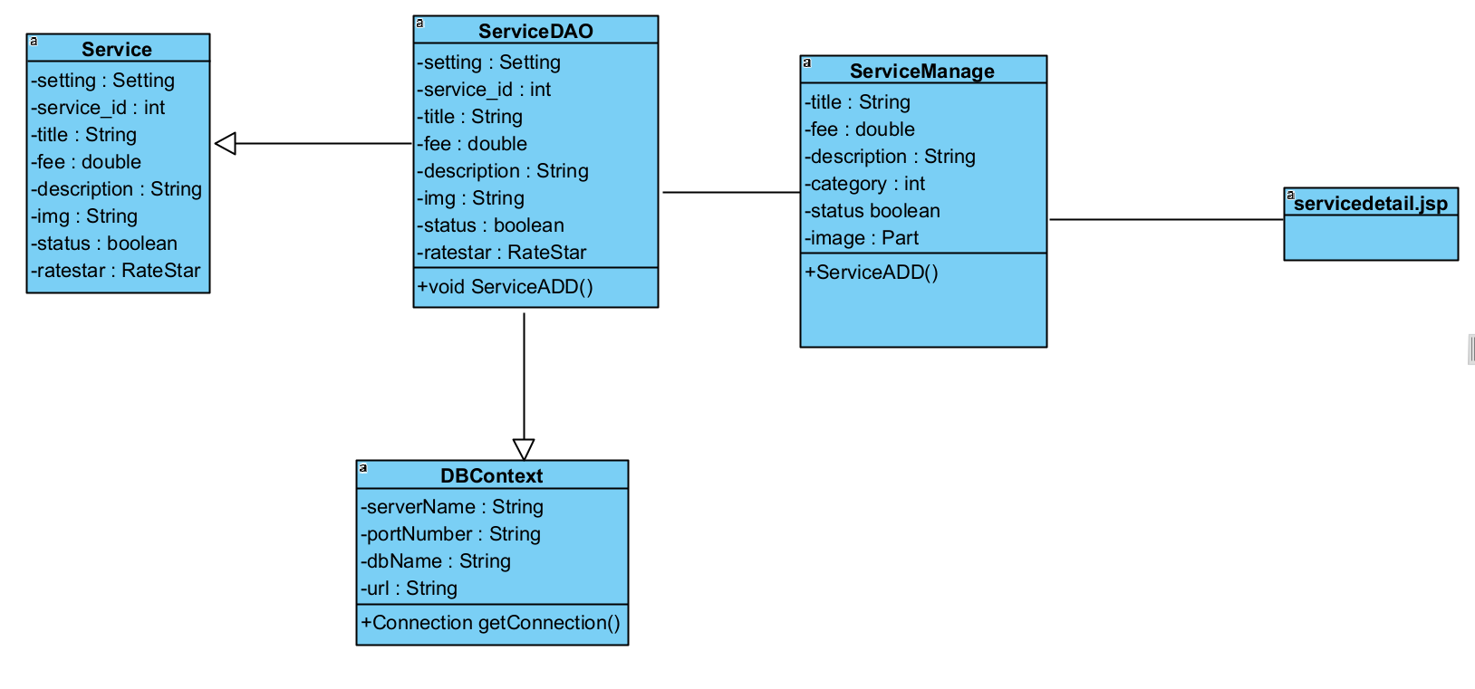

### **b.** **Class Specification**

| No | Method | Description |
| --- | --- | --- |
| 1 | ServiceADD() | using to add new service throw sql queries: INSERT INTO `doctris_system`.`service`  (`category_id`, `title`, `fee`, `description`, `img`, `status`) VALUES |

### **c. Sequence Diagram**

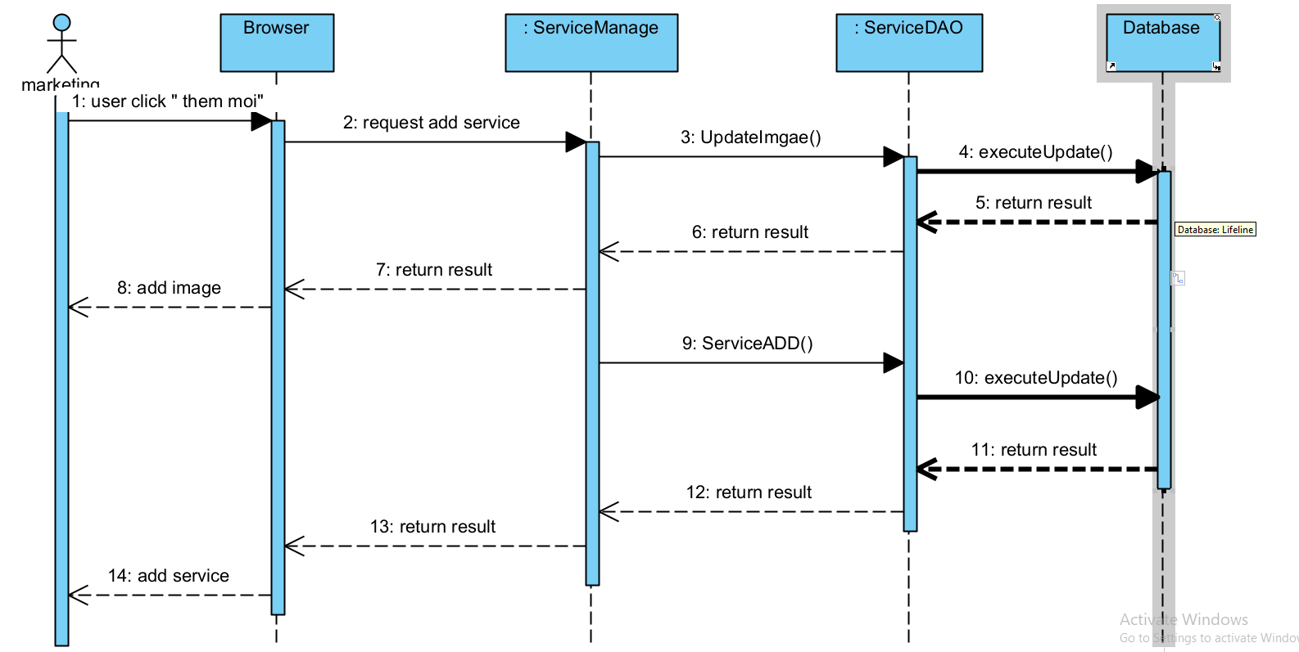

### **d. Database queries**

| No | Method | Database query |
| --- | --- | --- |
| 1 | ServiceADD() | INSERT INTO `doctris_system`.`service`  (`category_id`, `title`, `fee`, `description`, `img`, `status`) VALUES |

## **26. Marketing Feature/Service Edit**

### **a.** **Class Diagram**

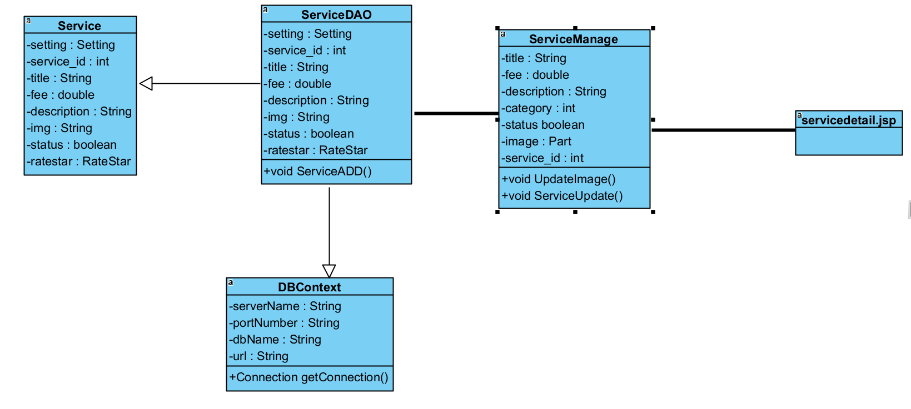

### **b.** **Class Specification**

| No | Method | Description |
| --- | --- | --- |
| 1 | ServiceUpdate() | using to update information service throw sql query: UPDATE `doctris_system`.`service`\n"  + "SET\n"  + "`category_id` = ?,\n"  + "`title` = ?,\n"  + "`fee` = ?,\n"  + "`description` = ?,\n"  + "`status` = ?\n"  + "WHERE `service_id` = ?" |
| 2 | UpdateImage() | using to update image service throw sql query: UPDATE `doctris_system`.`service`  SET  `img` = ?  WHERE `service_id` = ?; |

### **c. Sequence Diagram**

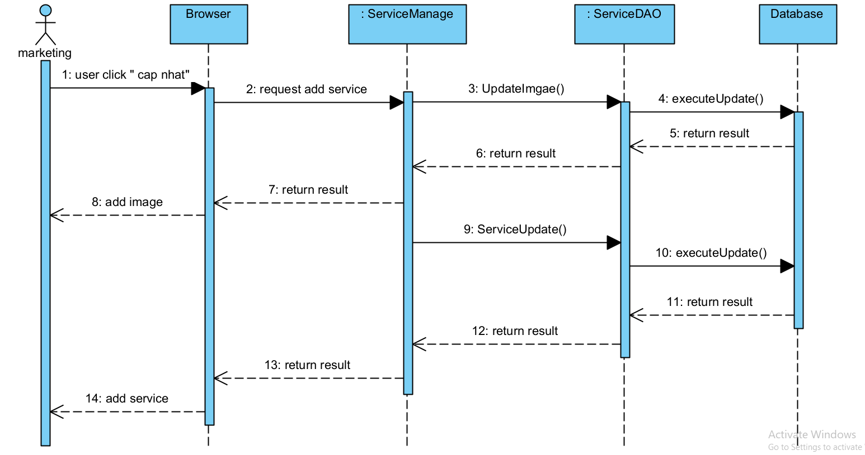

### **d. Database queries**

| No | Method | Description |
| --- | --- | --- |
| 1 | ServiceUpdate() | UPDATE `doctris_system`.`service`\n"  + "SET\n"  + "`category_id` = ?,\n"  + "`title` = ?,\n"  + "`fee` = ?,\n"  + "`description` = ?,\n"  + "`status` = ?\n"  + "WHERE `service_id` = ?" |
| 2 | UpdateImage() | UPDATE `doctris_system`.`service`  SET  `img` = ?  WHERE `service_id` = ?; |

## **27. Marketing Feature/Service List**

### **a.** **Class Diagram**

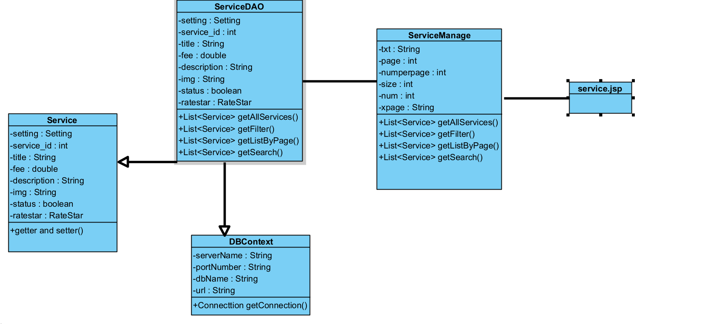

### **b.** **Class Specification**

| No | Method | Description |
| --- | --- | --- |
| 1 | getAllService() | List all doctor in database to website throw data query: SELECT service.service_id, service.title, category_service.name, service.fee, service.status FROM service  INNER JOIN category_service ON service.category_id = category_service.id ORDER BY service.service_id ASC; |
| 2 | Search() | Search service by name throw data query :SELECT service.service_id, service.title, category_service.name,  service.fee, service.status  FROM service  INNER JOIN category_service  ON service.category_id = category_service.id  WHERE service.title LIKE ?  ORDER BY service.service_id ASC; |
| 3 | getListByPage() | The method getListByPage() above has the function to retrieve a partial list of services (Services) from a complete list. |
| 4 | getFilter() | Filter service by specialize throw sql query: SELECT service.service_id, service.title, category_service.name, service.fee, service.status  FROM service  INNER JOIN category_service ON service.category_id = category_service.id  WHERE service.category_id = ?  ORDER BY service.service_id ASC; |

### **c. Sequence Diagram**

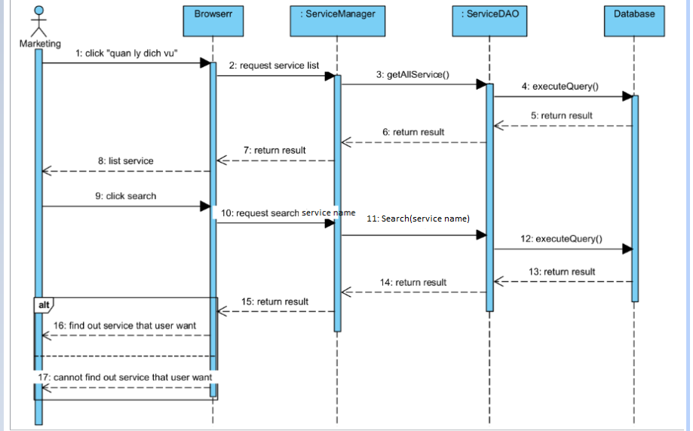

### **d. Database queries**

| No | Method | Database queries |
| --- | --- | --- |
| 1 | getAllService() | SELECT service.service_id, service.title, category_service.name, service.fee, service.status FROM service  INNER JOIN category_service ON service.category_id = category_service.id ORDER BY service.service_id ASC; |
| 2 | Search() | SELECT service.service_id, service.title, category_service.name,  service.fee, service.status  FROM service  INNER JOIN category_service  ON service.category_id = category_service.id  WHERE service.title LIKE ?  ORDER BY service.service_id ASC; |
| 3 | getFilter() | SELECT service.service_id, service.title, category_service.name, service.fee, service.status  FROM service  INNER JOIN category_service ON service.category_id = category_service.id  WHERE service.category_id = ?  ORDER BY service.service_id ASC; |

## **28. Marketing Feature/Blog list**

### **a.** **Class Diagram**

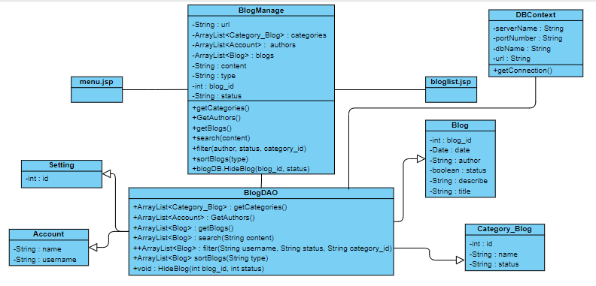

### **b. Class Specification**

| No | Method | Description |
| --- | --- | --- |
| 1 | getBlogs | get all blog in database order by date |
| 2 | getCategories | get all categories in database |
| 3 | getBlog | get blog by blog id |
| 4 | filter | The user can filter the post by category, author, status |
| 5 | search | get blog that having or contain keyword in its title |

### **c. Sequence Diagram**

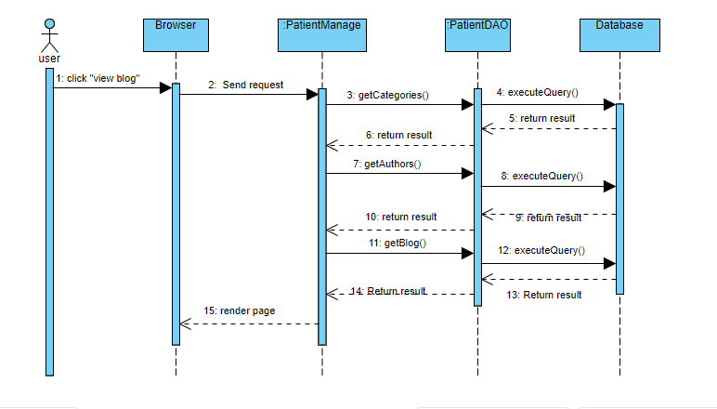

### **d. Database queries**

| No | Method | Database Queries |
| --- | --- | --- |
| 1 | getBlogs | SELECT blog.*, category_blog.name FROM blog inner join category_blog on blog.category_id = category_blog.id order by date desc |
| 2 | getCategories | Get * from category_blog |
| 3 | search | SELECT * FROM blog WHERE title LIKE ? ORDER BY date desc |

## 

## **29. Marketing Feature/Blog detail**

### **a.** **Class Diagram**

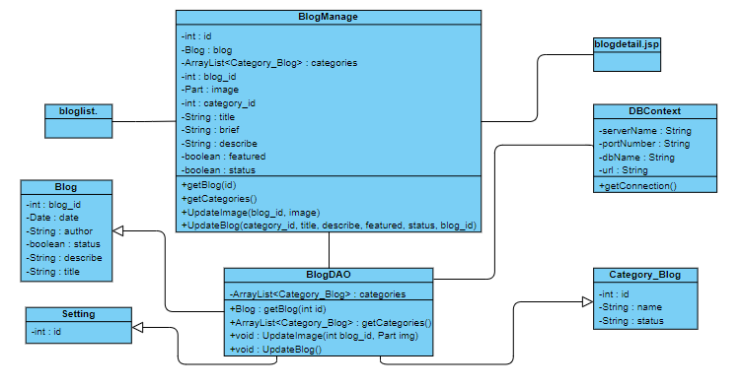

### **b. Class Specification**

| No | Method | Description |
| --- | --- | --- |
| 1 | getBlog(id) | Get blog by blog id |
| 2 | getCategories() | Get * from category_blog |
| 3 | UpdateBlog(category_id, title, describe, featured, status, blog_id) | Update table blog |
| 4 | UpdateImage(blog_id, image) | Update img with blog_id in table blog |

### **c. Sequence Diagram**

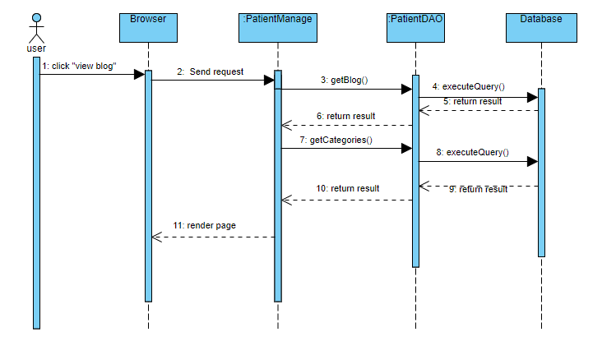

### **d. Database queries**

| No | Method | Database queries |
| --- | --- | --- |
| 1 | getBlog(id) | Select b.*, u.name as author, c.name as category_name  from blog as b\n"  Inner join users as u on b.username = u.username  inner join category_blog c on b.category_id = c.id  where b.blog_id = ?  order by b.date desc |
| 2 | getCategories() | SELECT * FROM category_blog |
| 3 | UpdateBlog() | UPDATE `doctris_system`.`blog` SET `category_id` = ?, `title` = ?, `describe` = ?, `featured` = ?, `status` = ? WHERE `blog_id` = ? |
| 4 | UpdateImage() | UPDATE `doctris_system`.`blog` SET `img` = ? WHERE `blog_id` = ? |

## **30. Marketing Feature/Blog Add**

### **a.** **Class Diagram**

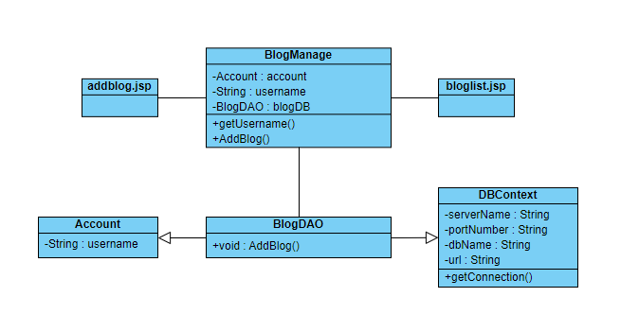

### **b. Class Specification**

| No | Method | Description |
| --- | --- | --- |
| 1 | getUsername() | get username from session |
| 2 | AddBlog() | insert into table blog |

### **c. Sequence Diagram**

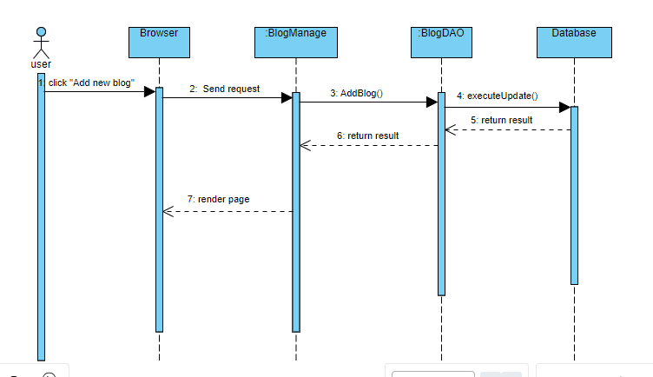

### **d. Database queries**

| No | Method | Database queries |
| --- | --- | --- |
| 1 | AddBlog() | INSERT INTO `doctris_system`.`blog` (`category_id`, `title`, `img`, `describe`, `date`, `featured`, `username`, `status`) VALUES ( ? , ? , ? , ? , curdate(), ? , ? , ? ) |

## 

## 

## 

## 

## 

## **31. Marketing Feature/Blog Edit**

### **a.** **Class Diagram**

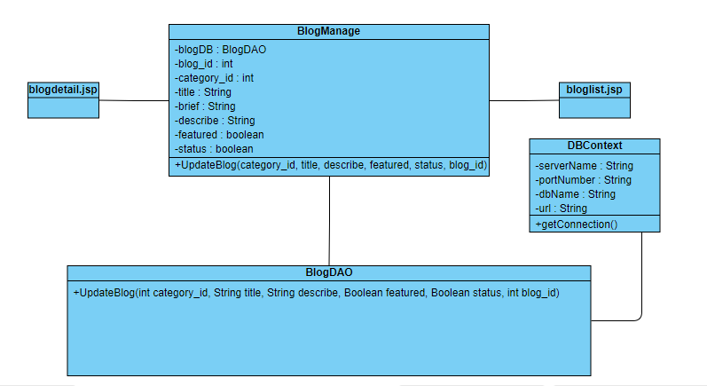

### **b. Class Specification**

| No | Method | Description |
| --- | --- | --- |
| 1 | UpdateBlog() | update detail blog in database |

### **c. Sequence Diagram**

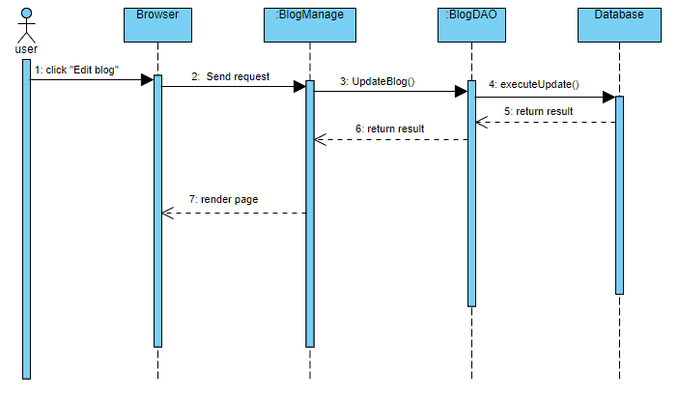

### **d. Database queries**

| No | Method | Database queries |
| --- | --- | --- |
| 1 | UpdateBlog(int category_id, String title, String describe, Boolean featured, Boolean status, int blog_id) | UPDATE `doctris_system`.`blog`  SET  `category_id` = ?,  `title` = ?,  `describe` = ?,  `featured` = ?,  `status` = ?  WHERE `blog_id` = ? |

## 

## **32. Common Feature/Web Blog Detail**

### **a.** **Class Diagram**

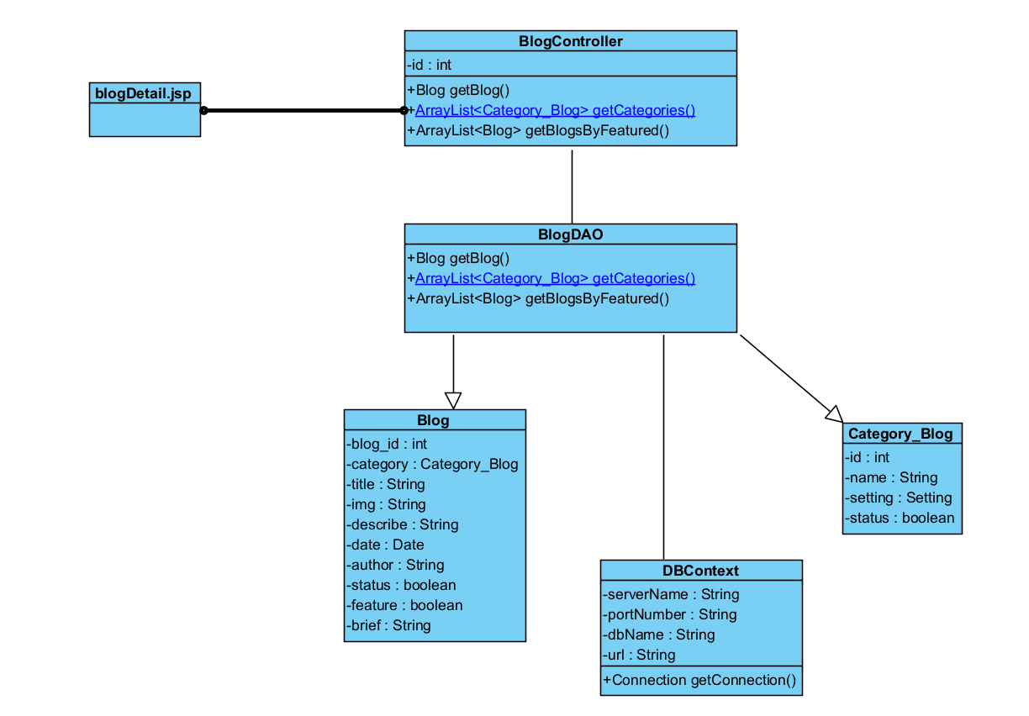

### **b. Class Specification**

| No | Method | Description |
| --- | --- | --- |
| 1 | getBlog() | get blog by blog id |
| 2 | getBlogByFeatured() | get blog which featured |
| 3 | getBlogByCategory() | get blog in the same category |

### **c. Sequence Diagram**

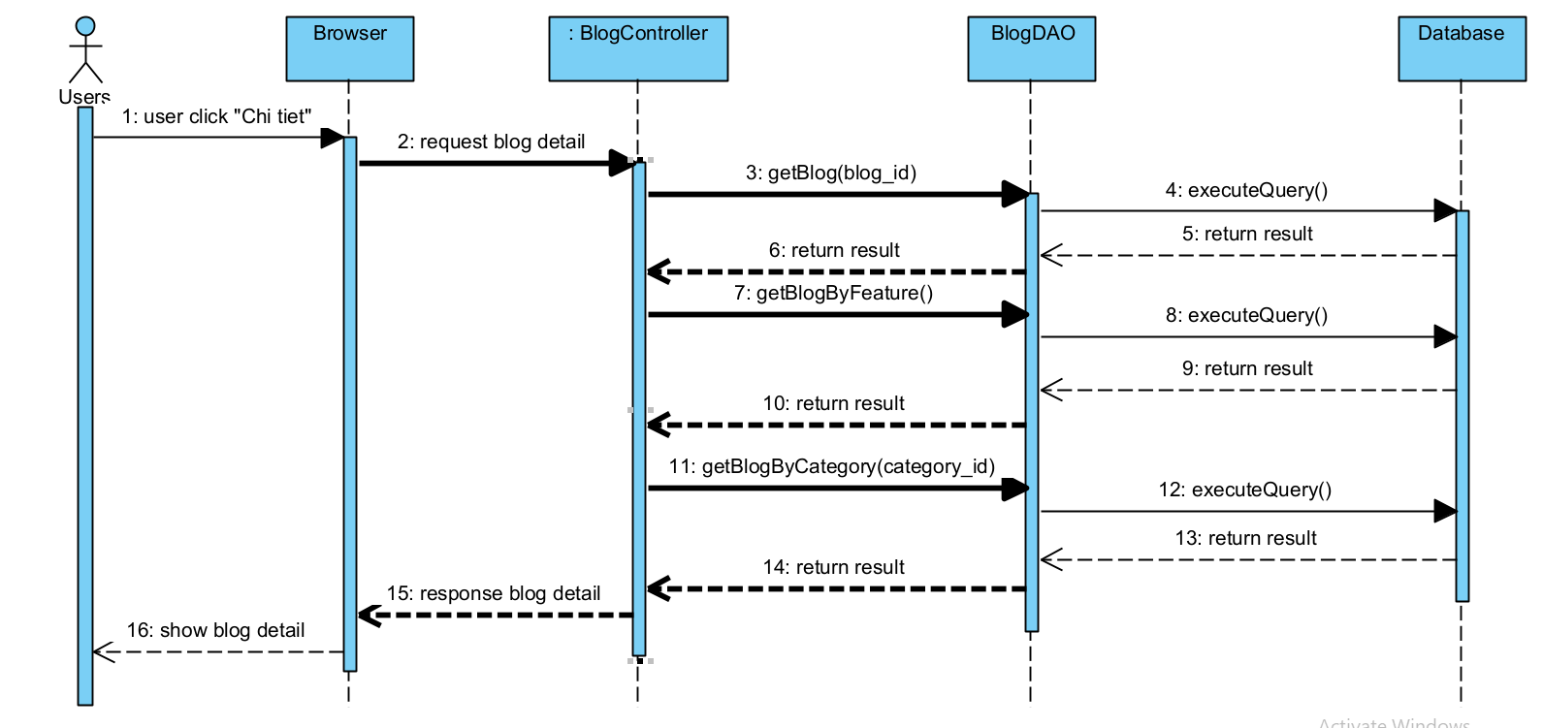

### **d. Database queries**

| No | Method | Database Queries |
| --- | --- | --- |
| 1 | getBlog() | SELECT b.*, u.name AS author, c.name AS category_name  FROM blog AS b  INNER JOIN users AS u ON b.username = u.username  INNER JOIN category_blog AS c ON b.category_id = c.id  WHERE b.blog_id = ?  ORDER BY b.date DESC |
| 2 | getBlogByFeatured() | Select * from blog where featured = 1 and status = 1; |
| 3 | getBlogByCategory() | SELECT b.*, c.name AS category_name  FROM blog AS b  INNER JOIN category_blog AS c ON b.category_id = c.id  WHERE category_id = ? AND b.status = 1  ORDER BY date DESC |

## 

## **33. Staff Feature/Appointments List**

## **a.** **Class Diagram**

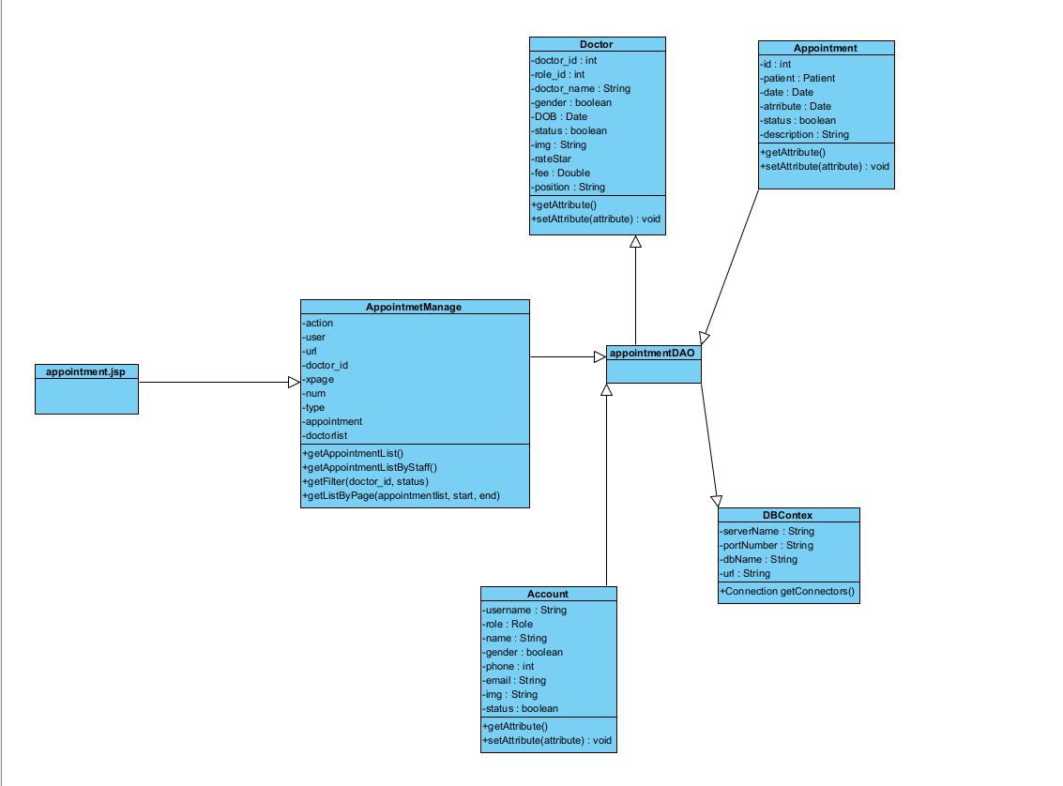

### **b. Class Specification**

| No | Method | Description |
| --- | --- | --- |
| 1 | getAppointmentListByStaff(user.getUsername()) | get appointment list by staff name |
| 2 | getDoctorNameAndID() | get list doctor by name and id |
| 3 | getFilterByStaff(doctor_id, status, user.getUsername(),date) | get filter staff by id, status, name, datedate |
| 4 | getListByPage(appointmentlist, start, end) | get list page by appointmentlist, start, end |

### 

### **c. Sequence Diagram**

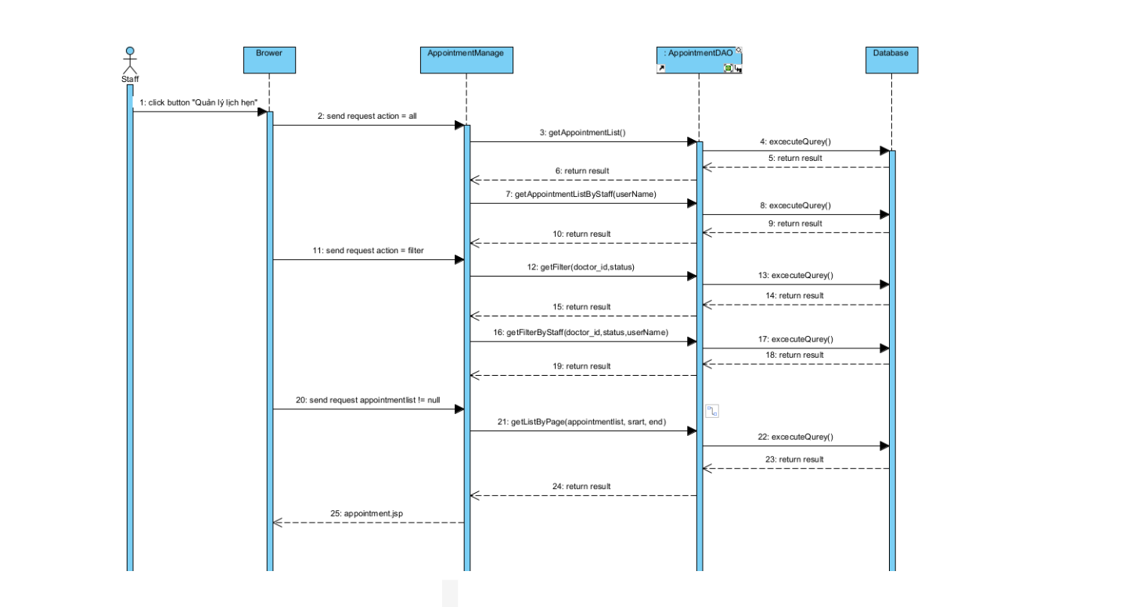

### **d. Database queries**

| No | Method | Database Queries |
| --- | --- | --- |
| 1 | getAppointmentListByStaff(user.getUsername()) | SELECT appointments.appointment_id, doctor.doctor_name, users.name, appointments.date, appointments.time, appointments.status  FROM appointments  INNER JOIN doctor ON appointments.doctor_id = doctor.doctor_id  INNER JOIN patient ON appointments.patient_id = patient.patient_id  INNER JOIN users ON patient.username = users.username  WHERE appointments.staff = ?; |
| 2 | getDoctorNameAndID() | select doctor_id, doctor_name from doctris_system.doctor |
| 3 | getFilterByStaff(doctor_id, status, user.getUsername(),date) | -- filterStatus  SELECT appointments.appointment_id, doctor.doctor_name, users.name, appointments.date, appointments.time, appointments.status  FROM appointments  INNER JOIN doctor ON appointments.doctor_id = doctor.doctor_id  INNER JOIN patient ON appointments.patient_id = patient.patient_id  INNER JOIN users ON patient.username = users.username  WHERE appointments.status = ? AND appointments.staff = ?;  -- filterDoctor  SELECT appointments.appointment_id, doctor.doctor_name, users.name, appointments.date, appointments.time, appointments.status  FROM appointments  INNER JOIN doctor ON appointments.doctor_id = doctor.doctor_id  INNER JOIN patient ON appointments.patient_id = patient.patient_id  INNER JOIN users ON patient.username = users.username  WHERE appointments.doctor_id = ? AND appointments.staff = ?;  -- filterDate  SELECT appointments.appointment_id, doctor.doctor_name, users.name, appointments.date, appointments.time, appointments.status  FROM appointments  INNER JOIN doctor ON appointments.doctor_id = doctor.doctor_id  INNER JOIN patient ON appointments.patient_id = patient.patient_id  INNER JOIN users ON patient.username = users.username  WHERE appointments.date = ? AND appointments.staff = ?;  -- filter  SELECT appointments.appointment_id, doctor.doctor_name, users.name, appointments.date, appointments.time, appointments.status  FROM appointments  INNER JOIN doctor ON appointments.doctor_id = doctor.doctor_id  INNER JOIN patient ON appointments.patient_id = patient.patient_id  INNER JOIN users ON patient.username = users.username  WHERE appointments.doctor_id = ? AND appointments.status = ? AND appointments.staff = ? AND appointments.date = ?; |
| 4 | getListByPage(appointmentlist, start, end) | for (int i = start; i < end; i++) {  arr.add(list.get(i));  } |

## 

## **34. Staff Feature/Appointments Detail**

### **a. Class Diagram**

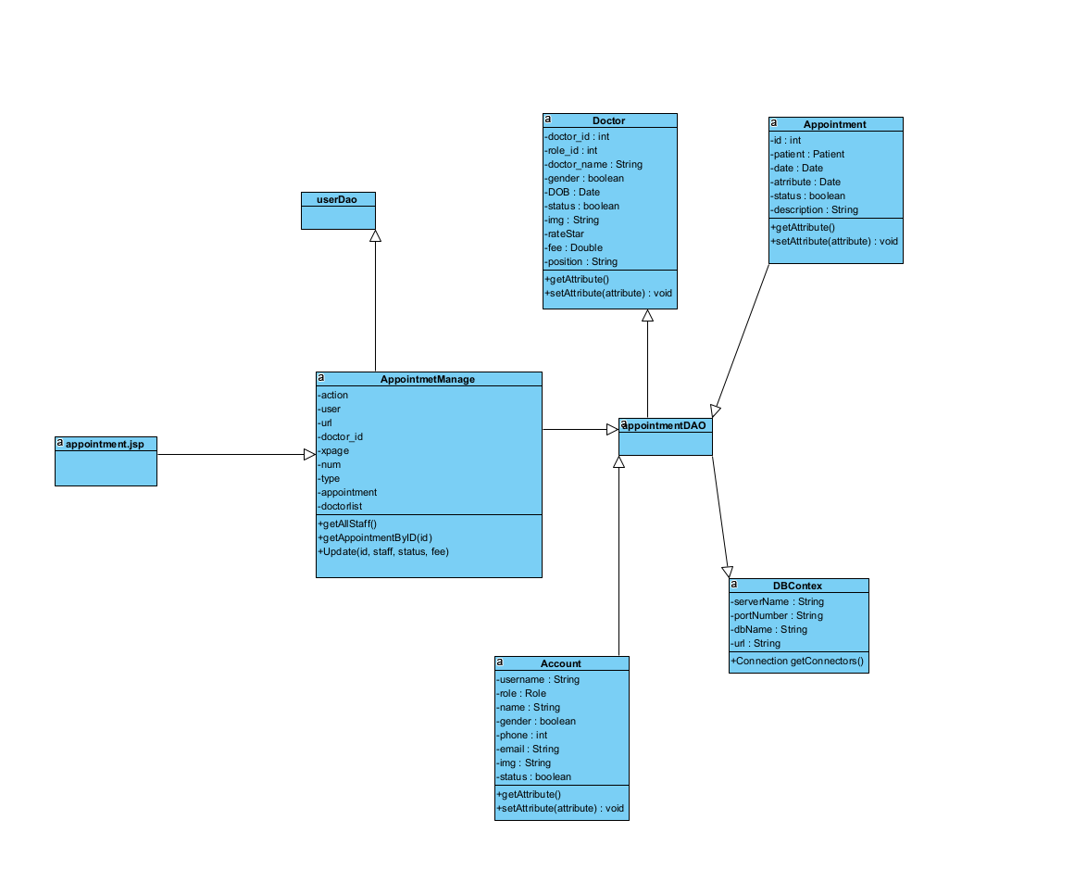

### **b. Class Specification**

| No | Method | Description |
| --- | --- | --- |
| 1 | getAllStaff() | get all staff |
| 2 | getAppointmentByID(id) | get all appointment by id |
| 3 | Update(id, staff, status, fee) | update information by id, staff, status,fee |

### 

### **c. Sequence Diagram**

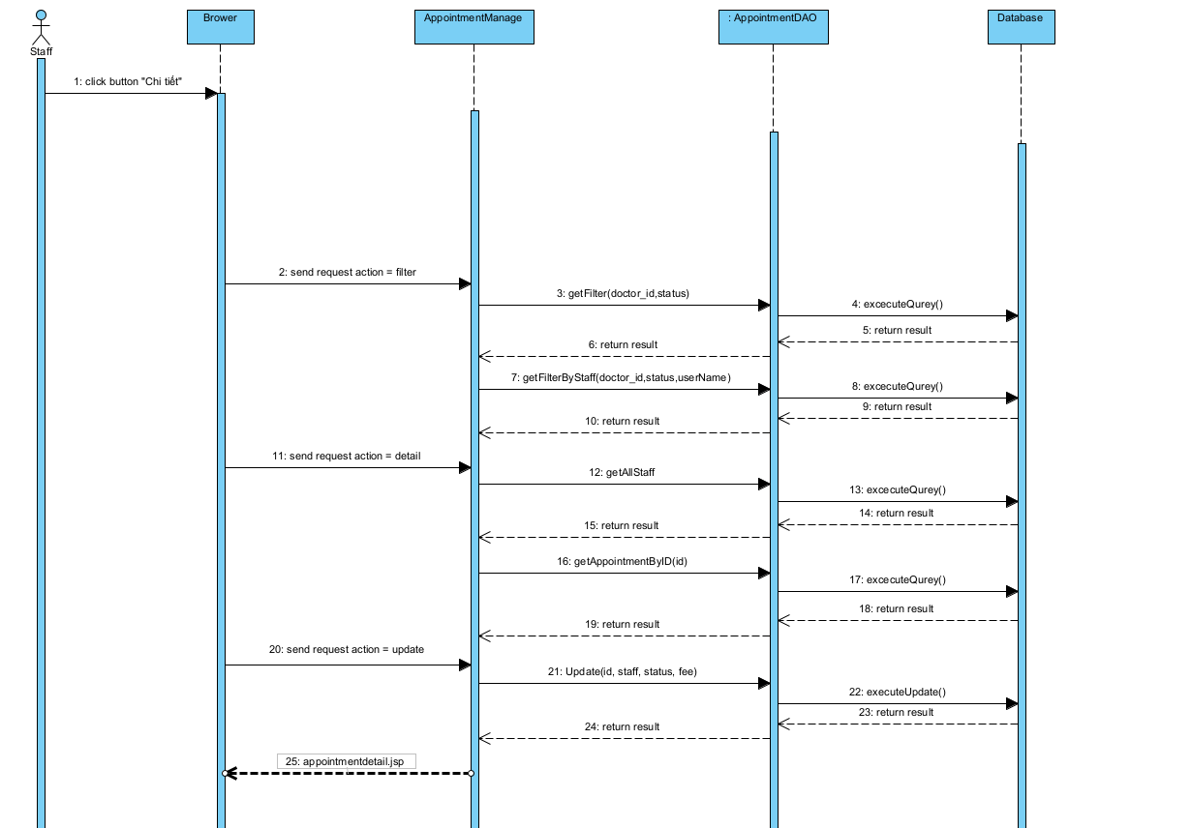

### **d. Database queries**

| No | Method | Database Queries |
| --- | --- | --- |
| 1 | getAllStaff() | SELECT username,name FROM doctris_system.users where role_id = 4 and status = 1 |
| 2 | getAppointmentByID(id) | SELECT doctor.img, doctor.doctor_name, doctor.phone, doctor.gender, category_service.name,  users.img, users.name, users.phone, users.gender, patient.DOB, appointments.date,  appointments.time, appointments.status, appointments.description, staff.name,  appointments.fee, appointments.appointment_id, staff.username  FROM appointments  INNER JOIN doctor ON appointments.doctor_id = doctor.doctor_id  INNER JOIN patient ON appointments.patient_id = patient.patient_id  INNER JOIN users ON patient.username = users.username  INNER JOIN users staff ON appointments.staff = staff.username  INNER JOIN category_service ON doctor.category_id = category_service.id  WHERE appointments.appointment_id = ?; |
| 3 | Update(id, staff, status, fee) | UPDATE `doctris_system`.`appointments` SET `staff` = ?, `status` = ?, `fee` = ? WHERE (`appointment_id` = ?) |

## 

# 

# 

# 

# 

## **35. Staff Feature/Doctor Edit**

### **a.** **Class Diagram**

# 

### **b. Class Specification**

| No | Method | Description |
| --- | --- | --- |
| 1 | UpdateImage() | Update new image of doctor |
| 2 | DoctorUpdate() | Update new information of doctor |

### **c. Sequence Diagram**

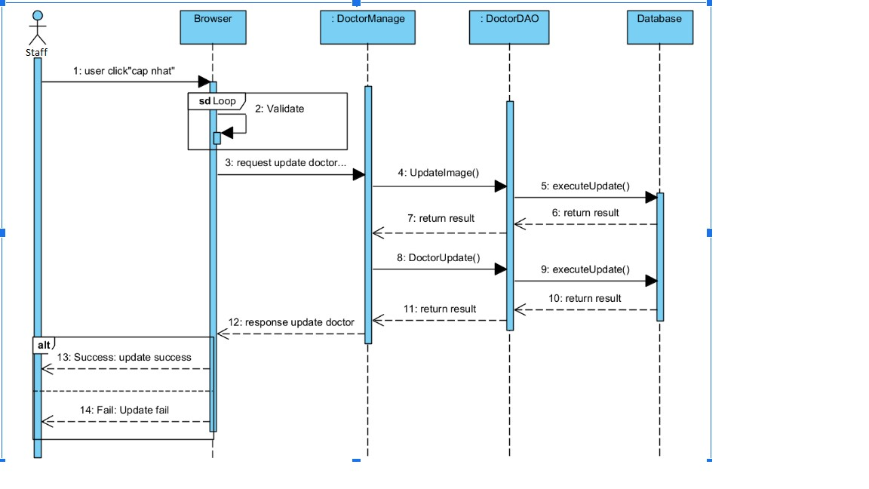

### **d. Database queries**

| No | Method | Database queries |
| --- | --- | --- |
| 1 | UpdateImage() | UPDATE `doctris_system`.`doctor` SET `img` = ? WHERE (`doctor_id` = ?) |
| 2 | DoctorUpdate() | UPDATE `doctris_system`.`doctor` SET `Category_id` = ?, `doctor_name` = ?, `gender` = ?, `DOB` = ?, `phone` = ?, `description` = ?, `status` = ? WHERE (`doctor_id` = ?) |

## **36. Staff Feature/Patients list**

### **a.** **Class Diagram**

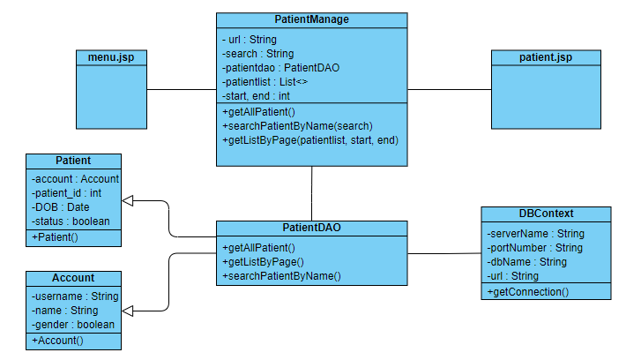

### **b. Class Specification**

| No | Method | Description |
| --- | --- | --- |
| 1 | getAllPatient() | get all patient in database |
| 2 | searchPatientByName() | search patient by name |
| 3 | getListByPage | Display page |

### **c. Sequence Diagram**

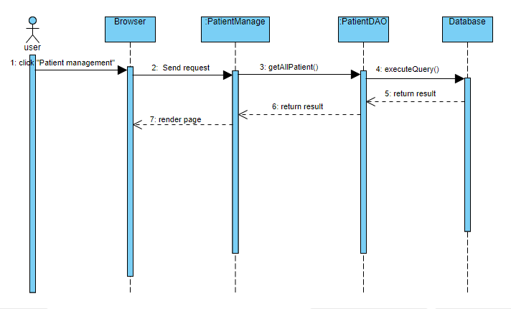

### **d. Database queries**

| No | Method | Database queries |
| --- | --- | --- |
| 1 | getAllPatient() | select p.patient_id,u.username,u.name,u.gender,p.DOB,p.status from doctris_system.patient p  inner join doctris_system.users u  on p.username = u.username |
| 2 | searchPatientByName(String name) | select p.patient_id,u.username,u.name,u.gender,p.DOB,p.status from doctris_system.patient p  inner join doctris_system.users u\n"  on p.username = u.username\n"  WHERE u.name LIKE N'%" + name + "%' |

## 

## 

## 

## 

## 

## 

## 

## **37. Staff Feature/Patient details**

### **a.** **Class Diagram**

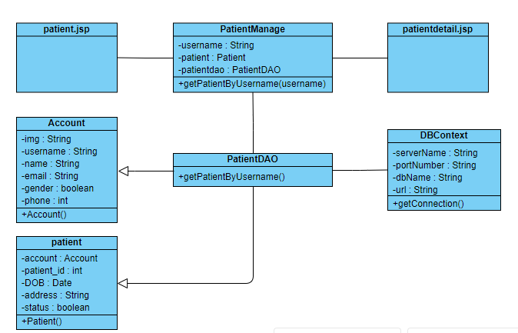

### **b. Class Specification**

| No | Method | Description |
| --- | --- | --- |
| 1 | getPatientByUsername() | get patient by username in database |

### **c. Sequence Diagram**

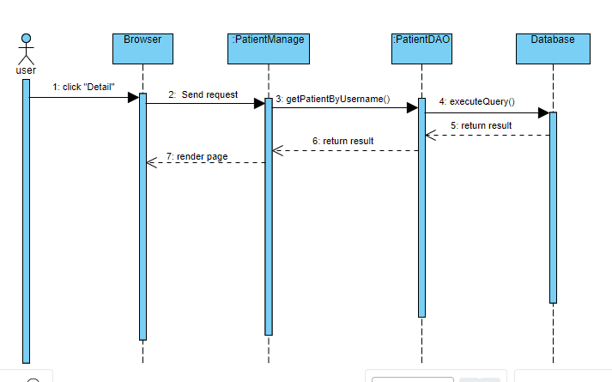

### **d. Database queries**

| No | Method | Database queries |
| --- | --- | --- |
| 1 | getPatientByUsername(String username) | select u.img, u.username,u.name,u.email,u.gender,u.phone,p.patient_id,p.DOB,p.address,p.status from patient p inner join users u  on p.username = u.username  where u.username = ? |

## 

## **38. Staff Feature/Patient edit**

### **a.** **Class Diagram**

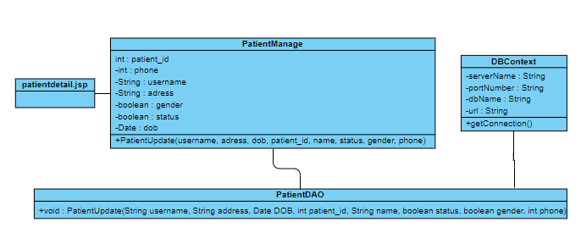

### **b. Class Specification**

| No | Method | Description |
| --- | --- | --- |
| 1 | PatientUpdate() | update in table patient and users |

### **c. Sequence Diagram**

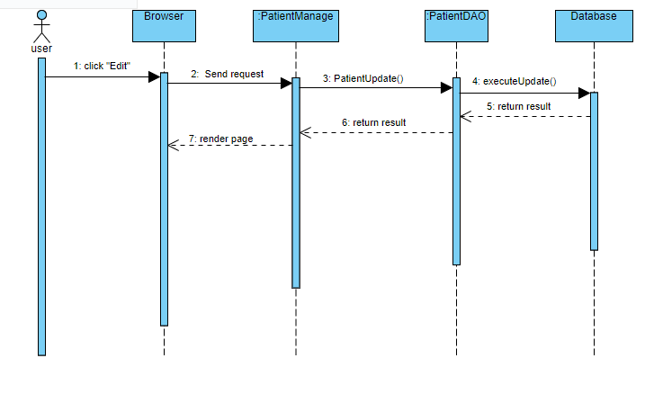

### **d. Database queries**

| No | Method | Database queries |
| --- | --- | --- |
| 1 | PatientUpdate() | UPDATE `doctris_system`.`patient` SET `address` = ?, `DOB` = ?, `status` = ? WHERE `patient_id` = ?  String sql2 = "UPDATE `doctris_system`.`users` SET `name` = ?, `gender` = ?, `phone` = ? WHERE `username` = ? |

## 

## **39. Staff Feature/Doctor Detail**

### **a.** **Class Diagram**

## 

### **b. Class Specification**

| No | Method | Description |
| --- | --- | --- |
| 1 | getDoctorByID() | get doctor by doctor id in database |
| 2 | getAppointmentByDoctor() | get appointment list by doctor id in database |

### **c. Sequence Diagram**

# 

# 

### **d. Database queries**

| No | Method | Database queries |
| --- | --- | --- |
| 1 | getAppointmentByDoctor() | SELECT appointments.appointment_id, doctor.doctor_name, users.name, appointments.date, appointments.time, appointments.status  FROM appointments  INNER JOIN doctor ON appointments.doctor_id = doctor.doctor_id  INNER JOIN patient ON appointments.patient_id = patient.patient_id  INNER JOIN users ON patient.username = users.username  WHERE doctor.doctor_id = ? |
| 2 | getRateDoctor() | SELECT users.name, users.img, ratestar.star, ratestar.feedback, ratestar.datetime  FROM ratestar  INNER JOIN users ON ratestar.username = users.username  WHERE ratestar.doctor_id = ?  ORDER BY ratestar.id DESC |
| 3 | getDoctorByID() | SELECT cs.name, d.doctor_id, d.role_id, d.doctor_name, d.username, d.gender, d.DOB, d.phone, d.description, d.status, d.img, u.email, d.fee, d.position  FROM doctris_system.doctor d  INNER JOIN doctris_system.category_service cs ON d.category_id = cs.id  INNER JOIN doctris_system.users u ON d.username = u.username  WHERE d.doctor_id = ? |

## 

# 

# 

# 

# 

# 

# 

# **III. Database Design**

## **1. Database Schema**

## 

## **2. Table Description**

| No | Table | Description |
| --- | --- | --- |
| 1 | User | username: VARCHAR  role_id: INT  password: VARCHAR  name: VARCHAR  gender: TINYINT  phone: INT  email: VARCHAR  - Primary keys: username  - Foreign keys: role_id |
| 2 | patient | patient_id: INT  username: VARCHAR  role_id: INT  patient_name:VARCHAR  gender:INT  DOB: DATE  phone: BIGINT  status: BIT  - Primary keys: patient_id  - Foreign keys: role_id |
| 3 | doctor | doctor_id: INT  role_id: INT  doctor_name: VARCHAR  username: VARCHAR  gender: BIT  DOB:DATE  phone:BIGINT  descriptionLONGTEXT  status:TINYINT  img:VARCHAR  - Primary keys: doctor_id  - Foreign keys: role_id |
| 4 | setting | setting_id: INT  setting_name:VARCHAR  description:LONGTEXT  - Primary keys: setting_id |
| 5 | service | service_id: INT  category_id: INT  title: VARCHAR  fee:DOUBLE  description: LONGTEXT  - Primary keys: service_id |
| 6 | blog | blog_id: INT  category_id: INT  title: VARCHAR  img: VARCHAR  describe: LONGTEXT  date: DATE  - Primary keys: blog_id |
| 7 | like_blog | username: VARCHAR  blog_id: INT  isLike: BIT  - Foreign keys: username |
| 8 | category_blog | id: INT  name: VARCHAR  setting_id: INT  status: TINYINT  - Primary keys: id  - Foreign keys: setting_id |
| 9 | comment_blog | username: VARCHAR  blog_id: INT  date: DATE  describe: LONGTEXT  - Foreign keys: setting_id |
| 10 | role | id: INT  name: VARCHAR  setting_id: INT  status:TINYINT  - Primary keys: id |
| 11 | category_service | id: INT  name: VARCHAR  setting_id: INT  status: TINYINT  - Primary keys: id  - Foreign keys: setting_id |
| 12 | reservations | reservation_id: INT  patient_id: INT  service_id: INT  price: DOUBLE  date: DATE  status: BIT  description: LONGTEXT  - Primary keys: reservation_id  - Foreign keys: patient_id, service_id |
| 13 | doctor_service | doctor_id: INT  service_id: INT  -Foreign - keys: doctor_id, service_id |
| 14 | ratestar | username: VARCHAR  doctor_id: INT  service_id: INT  star : INT  feedback: LONGTEXT  -Foreign - keys: username |
| 15 | appointments | appointment_id:INT  doctor_id: INT  patient_id: INT  date: DATE  status: BIT  description: LONGTEXT  - Primary keys: appointment_id  - Foreign keys: patient_id, doctor_id |
| 16 | timetable | service_id: INT  doctor_id: INT  date: DATE  start: TIME  end: TIME |